King Fahd University of Petroleum and Minerals

College of Mathematics and Computing

Department of Computer Engineering



**COE 485**

**Outdoor walking aid for the blind**

Term 212

**Supervised by Dr.Muhmmad Elrabaa**

|  |  |
| --- | --- |
| Name | ID |
| Hasan Alhussain | 201729330 |
| Omar Almatrudi | 201773270 |
| Hashim Altamaa | 201678700 |
| Mojtaba Almadan | 201774350 |

Date

2022/05/07

Contents

1. Introduction 1

1.1 Mobility challenges for the visually impaired 1

1.2 Possible approaches to solve the problem 1

1.2.1 Non digital approaches 2

1.2.2 Utilizing IoT 2

1.2.3 Utilizing smart glasses 3

1.2.4 Non autonomous mobile application 3

1.2.5 Autonomous mobile application (selected approach) 3

1.3 Potential impacts 5

2. Requirements, Specifications, and Constraints 6

3. Work plan 8

4. System design 9

4.1 Systems’ behaviour: Use-Cases 9

4.2 Product concept 14

4.3 System specifications 15

4.4 System architecture and deployment 16

4.5 Compliance with standards 17

5. Component’s design 18

5.1 Text recognition model 18

5.1.1 Tesseract-OCR (rejected) 18

5.1.2. Paddle OCR 20

5.1.3. Amazon Rekognition(selected) 22

5.2 Traffic light status detection model 23

5.2.1 Multiple Colour Detection 23

5.2.2 Colour circle detection(selected) 24

5.3 Obstacle detection model 26

5.3.1 Deploying Python solution on phone approach 26

5.3.2 Deploying native flutter solution on the phone (selected) 32

5.4 Text to speech convertor 35

5.4.1 Python TTS 35

5.4.2 Flutter TTS (Selected) 36

5.5 Mobile camera interface 36

5.6 Database 37

5.6.1 User credential management 37

5.6.2 User's live location 38

5.7 Cloud computing 42

5.7.1 How to deploy AI models on cloud 42

5.7.2 Deploying OCR model 47

5.7.3 Deploying traffic light model 48

5.7.4 API gateway 50

6. System integration and testing 51

6.1 Enrolment mechanism 51

6.2 Switching in-between modes 52

6.3 Text to speech 52

6.4 Live location 52

7. User interface 53

7.1 Figma 53

7.2 Native Flutter 53

Conclusion 54

References 56

Appendix 60

Tables

**Table 1, summary of discussed possible approaches.** 3

**Table 2, Summary of potential impacts of the selected approach.** 6

**Table 3. The requirements and corresponding specifications and constraints.** 6

[**Table 4 Work plan, project planning phase** 8](https://kfupmedusa.sharepoint.com/sites/Section_20588-Group5/Shared%20Documents/Group%205/Outdoor%20walking%20aid%20for%20the%20blind%20final%20report.docx#_Toc102763708)

**Table 5 Work plan, solution design phase** 8

[**Table 6 Work plan, solution implementation phase** 9](https://kfupmedusa.sharepoint.com/sites/Section_20588-Group5/Shared%20Documents/Group%205/Outdoor%20walking%20aid%20for%20the%20blind%20final%20report.docx#_Toc102763710)

**Table 7, enroll user use case description.** 10

**Table 8, Walk outside use case description.** 11

**Table 9, trace user use case description.** 12

**Table 10, The Health, Economic, Environmental, and the social constrains of this project are listed below.** 16

**Table 11, standards used for the project.** 17

**Table 12, categorization of objects' detection process.** 33

Figures

Figure 1, UltraCane direction limitation [8]. 2

Figure 2, IOT security issues [10]. 3

Figure 3, system use case diagram. 10

Figure 4. Product concept 1. 14

Figure 5, Product concept 2. 15

Figure 6. project architecture diagram. 16

Figure 7, project deployment diagram. 17

Figure 8 an illustration of a used OCR model 19

Figure 9 replace unnecessary character by an empty strig 19

Figure 10 the cropped image that OCR has been applied on 19

Figure 11.the resulting string of testing OCR after filtering & cropping 20

Figure 12 another bad result from OCR model 20

Figure 13 a snapshot of PaddleOCR test 21

Figure 14 error repeatedly faces in deploying paddleOCR 21

Figure 15: Error occurs when paddleocr is being installed 22

Figure 16 python code of text recognition using Amazon recognition 22

Figure 17 Testing the model deployed on lambda 23

Figure 18, sample test of rejected traffic light status model. 23

Figure 19, Red color test. 25

Figure 20 green colour test 25

Figure 21 distance of the detected colours 26

Figure 22: An Input Frame. 26

Figure 23: A Processed Frame. 27

Figure 24, object detection sample test. 33

Figure 25, inconsistency and mis-categorization of traffic lights at night. 34

Figure 26 a comparison between text file and audio file size 35

Figure 27, sample Python TTS code. 36

Figure 28, user record initialization. 37

Figure 29, user’s credentials dashboard in firebase. 37

Figure 30, caretaker page. 39

Figure 31, parameters observed by the user's application. 39

Figure 32, parameters observed by caretaker's application. 39

Figure 33, caretaker's page while collecting the location. 40

Figure 34, map view of user's live location. 41

Figure 35 error raised during running paddleOCR 42

Figure 36, potential architecture to be adopted in AWS for the project [27]. 42

Figure 37 Container vs. virtual machine 43

Figure 38 part of Docker file contains instructions to build a Docker image 44

Figure 39 Illustration of Docker file & Docker image and how the image will be deployed in a container 44

Figure 40 Illustration of pushing Docker image and deploying it on ECR 45

Figure 41 Illustration of the dataflow between the end user and ECR that stores Docker image 45

Figure 42 Architecture of using AWS Rekognition 46

Figure 43 Lambda function for OCR 47

Figure 44 Lambda handler for traffic light model 48

Figure 45 Push command used to push an image to ECR repository 49

Figure 46 Lambda function trigger added as an API gateway 49

Figure 47 API endpoint for a lambda function as a trigger 50

Figure 48, reset password email. 50

Figure 49, verify email message. 50

Figure 50. Figma design 52

Figure 51, Sample user interface with background image. 53

# Introduction

## Mobility challenges for the visually impaired

Blind people occupy a surprisingly large portion of worldwide citizens. Approximately three percent of children in the Unites States that are younger then eighteen are either fully blind or suffer from visual impairment [1]. Furthermore, most blindness cases are found in developing countries, where the eastern Mediterranean region accounts for almost 13% of them [2].

Unfortunately, technology’s advancements in visual aid for the blind have stagnated. Additionally, the issue is amplified by the fact that most people (including the blind) require access to computers and similar technologies in their daily life. On the other hand, visual aid technology that is available on the market is usually too costly for blind individuals, who often cannot work and provide finances for themselves [3]. The financial aspect of acquiring visual aid technologies is further reinforced by the struggle the blind face in finding and maintaining jobs, as they have a greater rate of unemployment compared to other people [4]. This poses safety problems as well, locally in Saudi Arabia, most traffic lights are not well suited for visually impaired individuals. As a matter of fact, blind people often express physical safety concerns in many scenarios, primarily on the street, and in public transportation [5]. Other outdoor struggles such as the recognition of useful hotspots such as stations and buildings along with their signs are often reported by the blind [6].

Providing cost effective visual aid for the visually impaired could substantially increase their quality of life. Visual aid could allow blind individuals to better connect and interact with the world around them. Moreover, visual aid could significantly improve the safety of the blind in a plethora of in-door and out-door environments. Furthermore, visual aid technology would suffice, as opposed to drastically overhauling city infrastructures to accommodate the visually impaired.

## Possible approaches to solve the problem

One of the challenges facing blind people is that a noticeable number of facilities are not designed with them as customers in mind. The aim of the project is to provide the necessary functions for blind people to have easier interaction with the open world. The following evaluated approaches are all about a mobile kit that would provide visual aid services for the user.

### 1.2.1 Non digital approaches

The approach is getting help from people, but this causes inconveniences to both parties. Other approaches are to have a guide dog to help in avoiding obstacles, or to have a cane, which helps the user in detecting surroundings [7][8]. However, a dog cannot read and needs caring, while the cane is limited to objects in front of the user and cannot detect far objects as can be seen in Figure 1 [7][8].

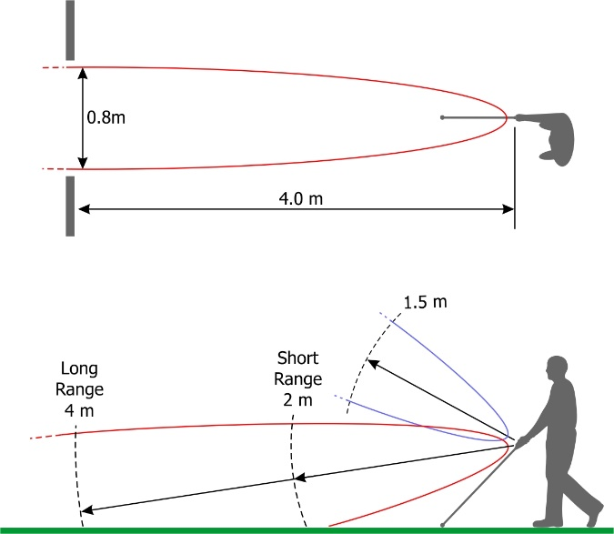

Figure 1, UltraCane direction limitation [8].

### 1.2.2 Utilizing IoT

A prominent and cost-effective approach would be to construct the system of multiple interrelated hardware components which would utilize the Internet of Things (IOT). However, the majority of end user hardware components require additional equipment (mainly camera and external battery) to be fully integrated onto the system to do many of the desired functionalities while being mobile. Additionally, IOT suffers from namouras privacy and security issues, which are summarized in Figure 2 [10].



Figure 2, IOT security issues [10].

### 1.2.3 Utilizing smart glasses

A promising approach to assisting the blind is utilizing smart glasses. Smart glasses are equipped with cameras that utilize AI to convert the blind user’s surroundings to useful speech. A major advantage of smart glasses is that they have been deployed in the market for a relatively long time. As a matter of fact, technology giants such as Google and Microsoft have developed smart glasses [14][16]. Existing smart glasses in the market convert text to speech, describe street signs and even do face recognition, while having a 5-to-6-hour battery life [15][16]. Unfortunately, smart glasses are extremely expensive, where they often start at around the 2000-dollar mark [15][16].

### 1.2.4 Non autonomous mobile application

Quite a few mobile applications have been developed in an attempt to help the blind. Visual aid smartphone applications offer great mobility, cost efficiency and easy accessibility, while facing difficulties regarding the ideal set up and camera angle on the user's side. Some applications in the market are used to connect a blind person’s live camera feed with a volunteer that would assist the user in a limited capacity [9] [11]. A major downside of the aforementioned methods employed by mobile applications is that the aid system is not autonomous and still requires the continuous input of a volunteer.

### 1.2.5 Autonomous mobile application (selected approach)

Nevertheless, the selected approach would still utilize a mobile application, as it offers a great amount of built-in peripherals (camera, speakers, …). Additionally, an application would be purely a service, as opposed to a physical product that would most probably increase potential maintenance time and accumulate additional costs. The applications would attempt to minimize the effort of setting up the system by having a default setup orientation and would maintain a mostly autonomous mode of operation, with minimal (human) external input.

Table 1 below summarizes the discussed approaches in terms of positive and negative aspects, where the row shaded in grey is the chosen approach.

**Table 1, summary of discussed possible approaches.**

|  |  |  |  |
| --- | --- | --- | --- |
| **Approach** | **Description** | **Pros** | **cons** |
| Getting help from people | Asking people on the street to assist the user in walking to a prespecified destination. | * Free and accessible | * Creates inconvenient situations to the user and helper * It is not guaranteed that someone would volunteer each time |
| utilizing guide dogs | Tying a leash to a dog and use them to help in avoiding obstacles on the street. | * Can help in detecting obstacles in multiple directions | * Dogs require constant care and maintenance * Dogs cannot help in reading signs or giving useful smart input |
| Utilizing a cane | Tapping the end of the cane to help the user get a better sense of their surroundings. | * Cheap * Suitable | * Can only detect object that are close to it, within a few meters |
| Utilizing IOT | Construct a system of independent hardware components that would utilize IOT to make a walking assistant. | * cheap | * IOT has many privacy and security concerns * Integrating many components, including peripherals would make costs unpredictable and increase the maintenance time |
| Utilizing smart glasses | Blind user wears smart glasses, and the glasses can extract useful visual information form their surroundings and convert it to speech. | * Product is thoroughly tested and has been on the market for a few years * Offers great battery life | * Extremely expensive |
| Non-autonomous phone application | Streaming the user’s camera feed to helped that would then give instructions via audio. | * Offers great mobility in terms of weight and size * Cost effective * Accessible * No other equipment is needed | * Requires constant human external input * Requires a specific camera angle set up on the user's side |
| Autonomous phone application | A user would maintain a specific camera angle and would use the camera to capture their surroundings, the system would then generate helpful instructions and issue necessary warnings when needed. | * Requires no human external input * Has great mobility * Cost effective * Accessible * No other equipment is needed | * Requires a specific camera angle set up on the user's side |

## Potential impacts

The mobile application would assist the user autonomously by receiving a portion of the camera feed, analyze it and return an audio output. To provide minimal delay on the application, a phone's computational power would not suffice, especially since computer vision is usually performance intensive.

As such, the application would utilize cloud computing. There are namouras environmental and health related negative impacts of the application electing to utilize cloud computing. Furthermore, there is significant waste of energy to maintain cooling systems for cloud data centers, which account for approximately 40% of their energy consumption [12]. Furthermore, chemicals that are often utilized in the cooling process of a cloud computing data center are considered hazardous and could potentially inflect harm on labor workers [13].

On the other hand, the proposed solution could tremendously improve the quality of life of blind users and their families and care takers. More specifically, the application would ease the process of commuting and allow users to grow more economically independent. Moreover, users would be able to avoid unnecessary physical injuries, due to them not being able to perceive their surroundings.

In terms of cost and spending, if the solution is utilized, indoor and outdoor facilities would not necessarily require redesigning, which is often expensive for local governments and enterprises.

Reliance on cloud computing exposes the processed data to multiple privacy and security risks. APIs and interfaces could be abused by attackers to compromise the user’s data due to issues associated with improper authentication and authorization (user privileges) [17][18]. Additionally, consumers lack the assurance that their information follows privacy compliance standards [17].

The cloud has introduced namouras new jobs in the global job market that are related to information technology (IT), networking and software, among other technical fields as well [19][20]. With the continuous technological revelations in cloud computing, experienced and inexperienced job seekers now have a new field in which they could employ their skills in.

Table 2 below, summarizes the potential impact of the elected approach in terms of economy, health, environment, and society.

**Table 2, Summary of potential impacts of the selected approach.**

|  |  |  |
| --- | --- | --- |
|  | **Positive Impact** | **Negative Impact** |
| **Economic Impact** | * Allows blind people to be independent and contribute to society. * Reduces the cost for local governments and enterprises to redesign buildings to be suitable for the blind. |  |
| **Health Impact** | * Blind people can avoid physical injuries more often. | * Cloud maintenance workers are exposed to hazardous chemicals. * Radiations of low frequency could affect the body of on-site workers. |
| **Environmental Impact** |  | * Inefficient energy usage for maintenance. * Usage of harmful chemicals. * More computing leads to more energy use. |
| **Societal Impact (people’s welfare and safety)** | * Improve quality of life for the blind and their families. * Creating new jobs. | * Security and privacy concerns. |

# Requirements, Specifications, and Constraints

The requirements and the corresponding specifications and constraints are listed in table 3 below.

**Table 3. The requirements and corresponding specifications and constraints.**

|  |  |  |  |
| --- | --- | --- | --- |
| Requirements | Corresponding specifications | Corresponding constraints | Justification |
| The system shall recognize text in useful signs. | Using OCR to extract text from the images. | Works only for the English language. |  |
| The system shall be able to convert a text to an audio speech. | Using text to speech locally on the phone. |  | Transmitting an audio file from the cloud to the phone would be much slower and would have greater size. |
| The system shall be able to recognize a traffic light status. | Using colour recognition model. | The distance should not be more than 12m as can be seen in testing section in figure 21. | The model cannot detect objects on a long distance, or the camera resolution. |
| The system shall inform the user about the status of the traffic light. | Converting the status of the traffic light into speech. |  | So, the user will have time to cross the road. |
| The system shall allow the caretaker to track the live location of the user. | The live location of the user is updated every 2 seconds. |  | Cost, otherwise, if the database is queried too many times, the free tier would not suffice [23]. |
| The system shall work for at least 5 hours. | Utilizing phone battery. | The battery capacity is not enough for the system. | The battery life for the phone is low or there are applications on the background consuming the battery. |
| The system shall detect obstacle/object such as street obstacles, traffic lights, street signs. | The system detects and reports only one object, which it has the most confidence in. | Some objects are miscategorized by the model. | Reporting more than one object simultaneously would lead to spamming the TTS, if delay is added, performance would degrade. |
| The system shall be used in different modes. | Switching in-between modes is done through swiping the screen. | The blind user is not able to navigate the application through buttons and text fields. | The user does not want the system to recognize text or traffic light all the time. |
| The system shall return result within two seconds. | For the traffic light and OCR, a frame is sent to the cloud every 5 seconds. |  | To reduce the number of queries and hence cost, and to not spam the TTS feature. |

# Work plan

The documentation and report writing portion of the project is to be done continuously from the start, while the other planned tasks are shown in Table 4,5, and 6. Each date represents the start of the week, and the phases are divided and illustrated in separated tables.

**Table 4 Work plan, project planning phase**

**Table 5 Work plan, solution design phase**

**Table 6 Work plan, solution implementation phase**



# System design

## Systems’ behaviour: Use-Cases

Figure 3 below displays the use case diagram of the outdoor walking aid project. There are two actors, the blind user and the blind user’s caretaker.

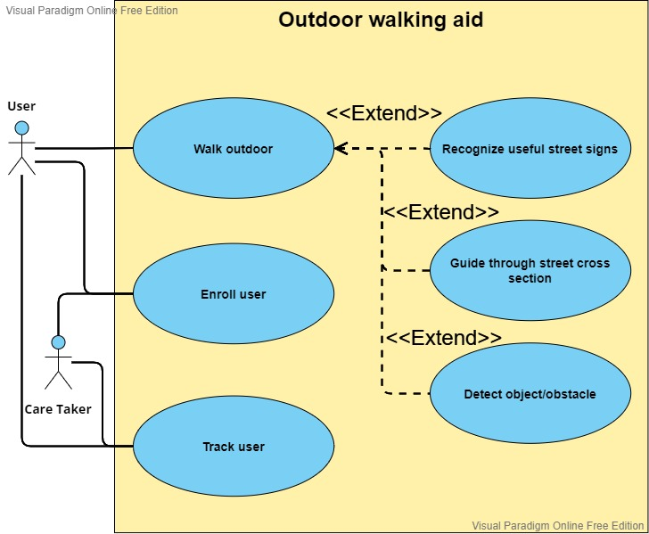

Figure 3, system use case diagram.

Each of the three main use cases (walk outdoor, enroll user, and trace user) are detailed in separate tables that can be observed below. Table 5 examines the enroll user use case in more detail.

**Table 7, enroll user use case description.**

|  |  |
| --- | --- |
| **Use-Case** | Enrol user. |
| **Actor(s)** | Caretaker and user. |
| **Related Use-Cases** | None. |
| **Trigger (Pre-Condition)** | A caretaker or a blind user login or sign up for the application. |
| **Description** | A caretaker will enrol both himself and the user. After a successful enrolment process a database record would be initialized for the blind user. |
| **Activity diagram** |  |
| **Post Condition** | The caretaker and user will be able to utilize the application. |

The Walk outdoor use case in Figure 3 is further explained in table 6, as can be seen below.

**Table 8, Walk outside use case description.**

|  |  |
| --- | --- |
| **Use-Case** | Walk outdoor. |
| **Actor(s)** | User. |
| **Related Use-Cases** | Recognize useful street signs, guide through street cross section and detect objects, which are all extending as can be seen in Figure 3. |
| **Trigger (Pre-Condition)** | The user would activate walking outside page and choose the desired mode (either of the extending use cases), while setting up the orientation of the device properly. |
| **Description** | The user would walk outdoor and encounter one of the three possible scenarios in which the system may help them. The scenarios are to read useful signs, to detect obstacles and objects on the road, and to guide through the traffic light cross section. The feedback of the application is done through audio instruction. |
| **Activity diagram** |  |
| **Post Condition** | The user would receive helpful information of safety instructions via audio. |

The trace user use case in Figure 3 is further explained in table 7, as can be seen below.

**Table 9, trace user use case description.**

|  |  |
| --- | --- |
| **Use-Case** | Track user. |
| **Actor(s)** | User and caretaker. |
| **Related Use-Cases** | Enrol user. |
| **Trigger (Pre-Condition)** | The caretaker would request the live location of a specific user. |
| **Description** | The caretaker would ask for the live location of the user that their account is associated with, the user`s application would update their live location on the database. In tandem, the reported location would be displayed on the caretaker’s side in a map. |
| **Activity diagram** |  |
| **Post Condition** | The caretaker would be able to see the live location of the user. |

## Product concept

The main concept is that a mobile application that is installed on the blind user’s phone would whenever the camera points towards things, output an audio readout of that thing depending on the mode, as can be observed in Figure 4.

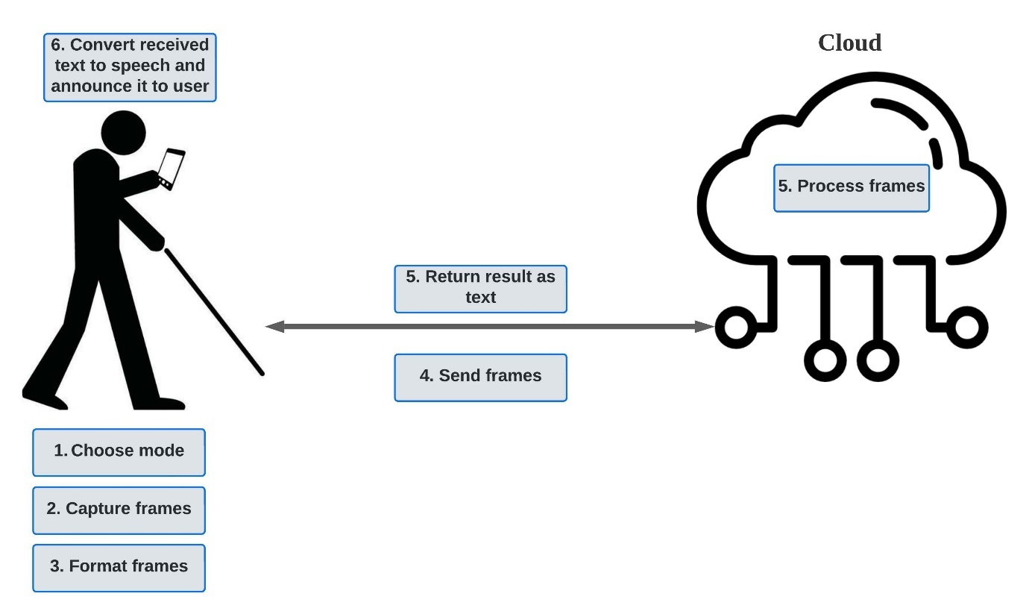

Figure 4. Product concept 1.

It must be clarified that the scenario in Figure 4 is the general one, where alternatively, the processing of the frame could happen on the blind user’s phone depending on the chosen mode.

Also, there will be a caretaker user that would enrol himself and their blind user, and could track the user’s location, as can be seen in Figure 5.

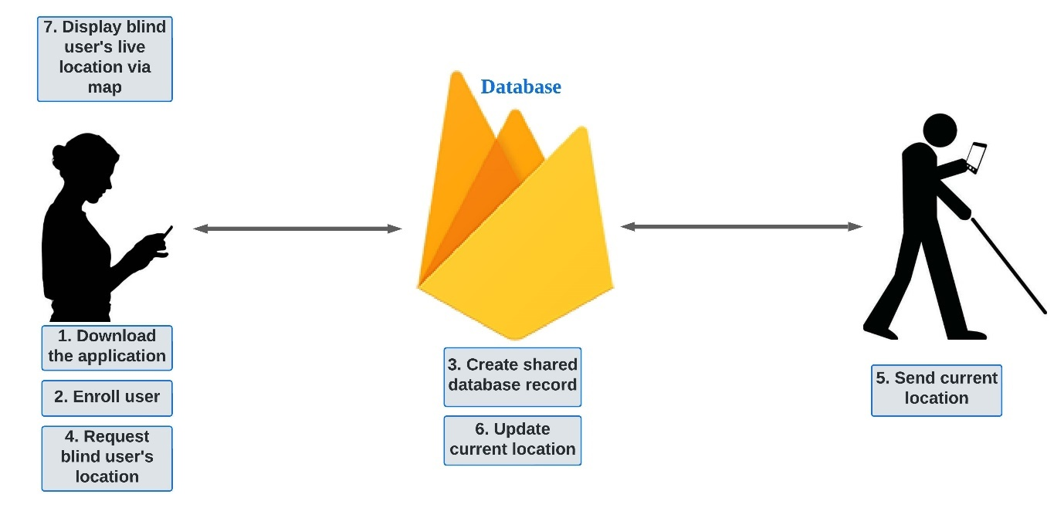

Figure 5, Product concept 2.

## System specifications

* Latency

The required latency must be less than 5s, so that the response comes back before sending the new request. Because there will be a new request every 5s when the user uses traffic light status or the OCR.

* Bandwidth

To get the required bandwidth, the size of the payload over the latency. The maximum photo was sent by the phone is 770.7 kB and the latency is 5s due to sending requests every 5s and the response comes before the 5s finishes. The bandwidth equals to 770.7k*8/5 = 1.23 Mb/s.

* Security

The security is unfortunately not implemented.

* Battery

Battery capacity in smartphones are between 3500 and 4000 in mAh and it is around 13.6Wh[35] and our system power consumption is close to WhatsApp because it just send text and pictures, so the power consumption of WhatsApp and it consume around 5.65 mAh and 0.98 W[34], this will be compared to the capacity of the smartphones batteries, and that is sufficient for our requirement.

* Human machine interface

The system will utilize the phone by using camera, screen, and speakers.

**Table 10, The Health, Economic, Environmental, and the social constrains of this project are listed below.**

|  |  |
| --- | --- |
| Design Factor | Consideration |
| Economic Impact | Cloud cost, hardware approach, hardware processing. |
| Health Impact | - |
| Environmental Impact | - |
| Social Impact | - |

## System architecture and deployment

Figure 6 below shows the architecture diagram of the outdoor walking aid project. It illustrates the main components and the connections between them. Firstly, there is one interface which is the mobile camera of the user's mobile. For the nodes, there are two end nodes which are caretaker's mobile and user's mobile. However, each of those end nodes will be connected to a sharable cloud. The caretaker mobile requests and receives a user's location, whereas the mobile user sends video frames and geographical location, and at the same time it receives report instructions sent by the cloud. In addition, the cloud processes the frames as desired and sends back the output instruction as well as forwarding the user's location to the caretaker, but for detecting obstacles, it is done locally on the blind user’s mobile phone.

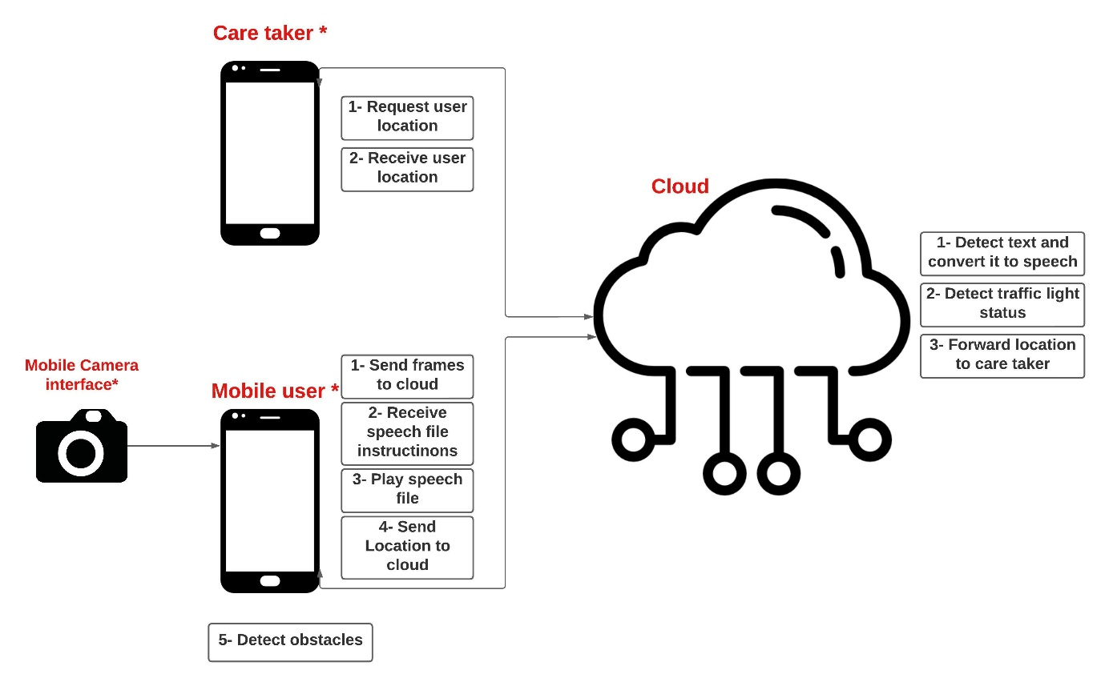

Figure 6. project architecture diagram.

Figure 7 below shows the deployment diagram of the outdoor walking aid project. It illustrates where each component exists and how the nodes communicate with each other. First, there is a database which is Google firebase and there is also a cloud which is Amazon AWS. For Google firebase, it stores the user’s location along with their credentials, it will be communicating with mobile user via Web socket, whereas AWS, which contains text OCR model, and detector of traffic light status model, will use HTTP. As for the obstacle detection model, it will run natively on the blind user’s phone. For end nodes, caretaker mobile contains live map feed, whereas the user’s mobile contains video frame sender, text to speech converter, and live location tracker.

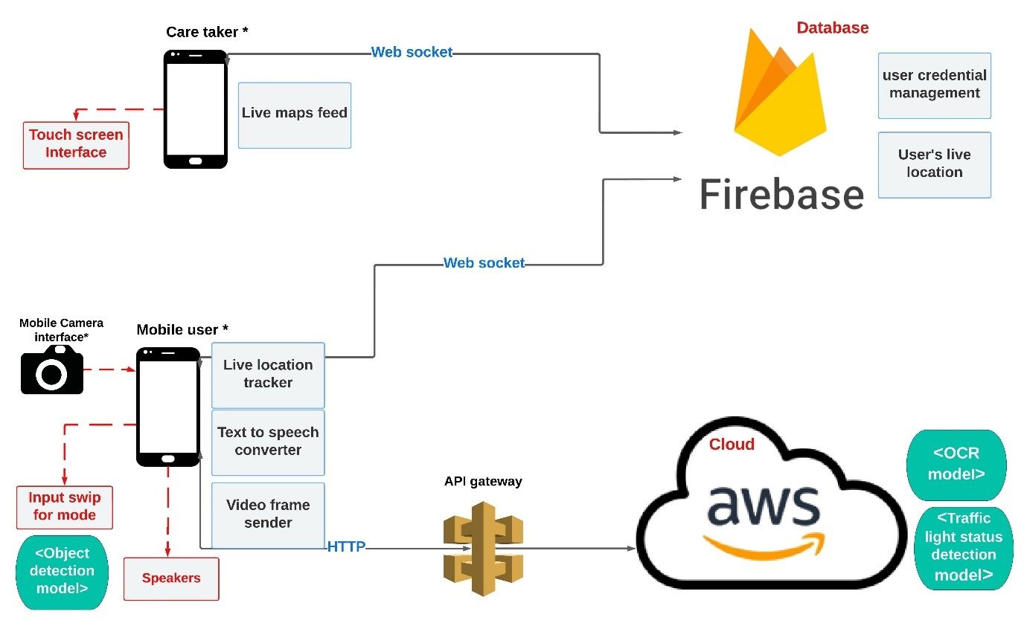

Figure 7, project deployment diagram.

## Compliance with standards

Table 11 below summarizes the protocols that are utilized for the project. Protocols mentioned are mostly dictated by the service utilized, and whether said protocol is supported or not.

**Table 11, standards used for the project.**

|  |  |  |
| --- | --- | --- |
| **Standard** | **Purpose** | **Where & why it is used** |
| HTTP | Restful (post and get) commands used to exchange data. | * Used by end user to communicate with the cloud’s API (gateway). * Used to retrieve and upload necessary data needed for the cloud to process. |
| Websocket | Opens bidirectional, fast channel to frequently update and query the location and enrolment database. | * Used by end user to update their location every set number of seconds. * Used to manage the accounts registered with the app. |
| WiFi | Connecting end devises running the application with the needed cloud provider. | * Required to be able to connect to any cloud provide and utilize their services. * Required to determine user’s location (longitude and latitude). |
| NoSQL | Query and edit location and user records’ database entries. | * Used by the database, and allows the user to write, overwrite and retrieve data within specified collection. |
| MP3 | A format to handle audio files. | * Used on the phone’s side to receive useful string from a variety of sources and convert the text to speech. |
| JPEG | A format to handle images taken by the phone’s camera. | * Used at the cloud’s side as input to get useful output depending on the model utilized. * Used on the phone as input to get results of some of the things that the phone processes. |
| JSON | Used to tie the app with the specific Firebase database. | * To utilize either firebase or and any of Google’s API’s, a JSON file that is unique to this project must be embedded into one specific class in the program. |

# Component’s design

## Text recognition model

### Tesseract-OCR (rejected)

There was a candidate Optical Character Recognition (OCR) model which was tested locally and rejected at the end. This model, which is obtained from geeks for geeks [44], uses OpenCV with Tesseract-OCR to detect texts in images. After testing the model, the resulted texts showed a very poor performance, as shown below where the text string detected is highlighted.

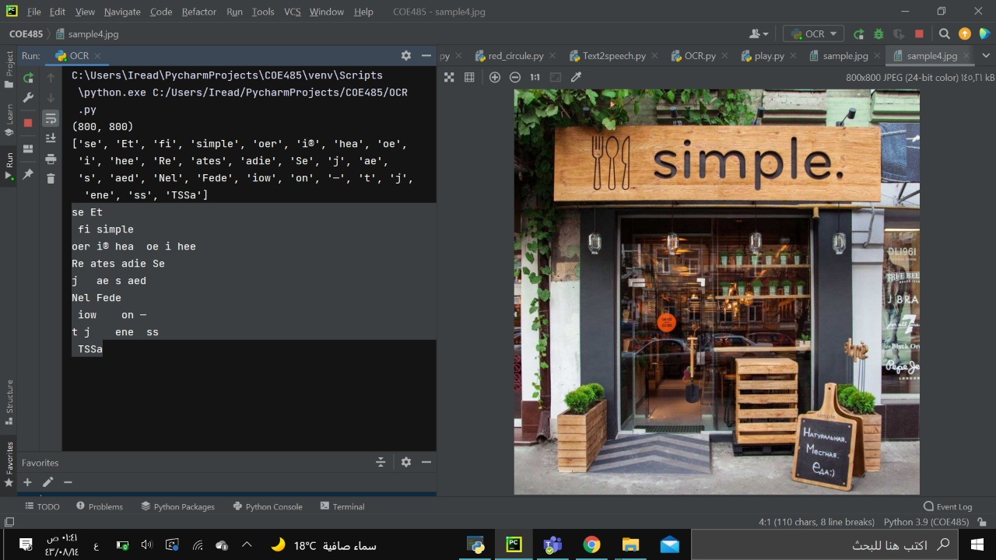

Figure 8 an illustration of a used OCR model

It appears that this model is sensitive to noise and generates unnecessary characters, in this application, such as special characters (?.,#/-_) or single character with no meaning. Therefore, one approach is to filter the detected text and search for those unnecessary characters and remove them. This is done via replacing a list of characters by an empty string as shown below.

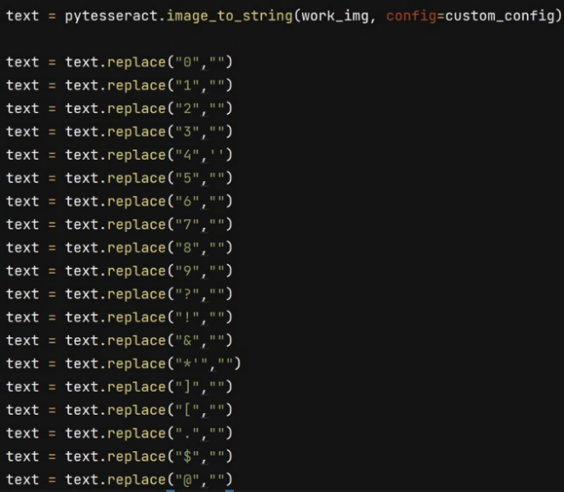

Figure 9 replace unnecessary character by an empty strig

Furthermore, the code is modified so that the image it cut and only the upper part appears to focus on the string and to apply a test where the user reads a shop name for example. However, the result was enhanced much better as shown below where figure 10 shows the cropped image, and figure 11 shows the detected string [‘oS’, ‘See’ ,’il’, ‘simple’] and after filtering it becomes see simple.



Figure 10 the cropped image that OCR has been applied on

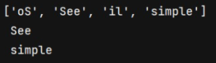

Figure 11.the resulting string of testing OCR after filtering & cropping

Further tests show that this model is meant to recognize texts in digital images and not good enough to detect texts in real images, as shown in figure 12 below where the generated string is meaningless and has no relationship with the real string.

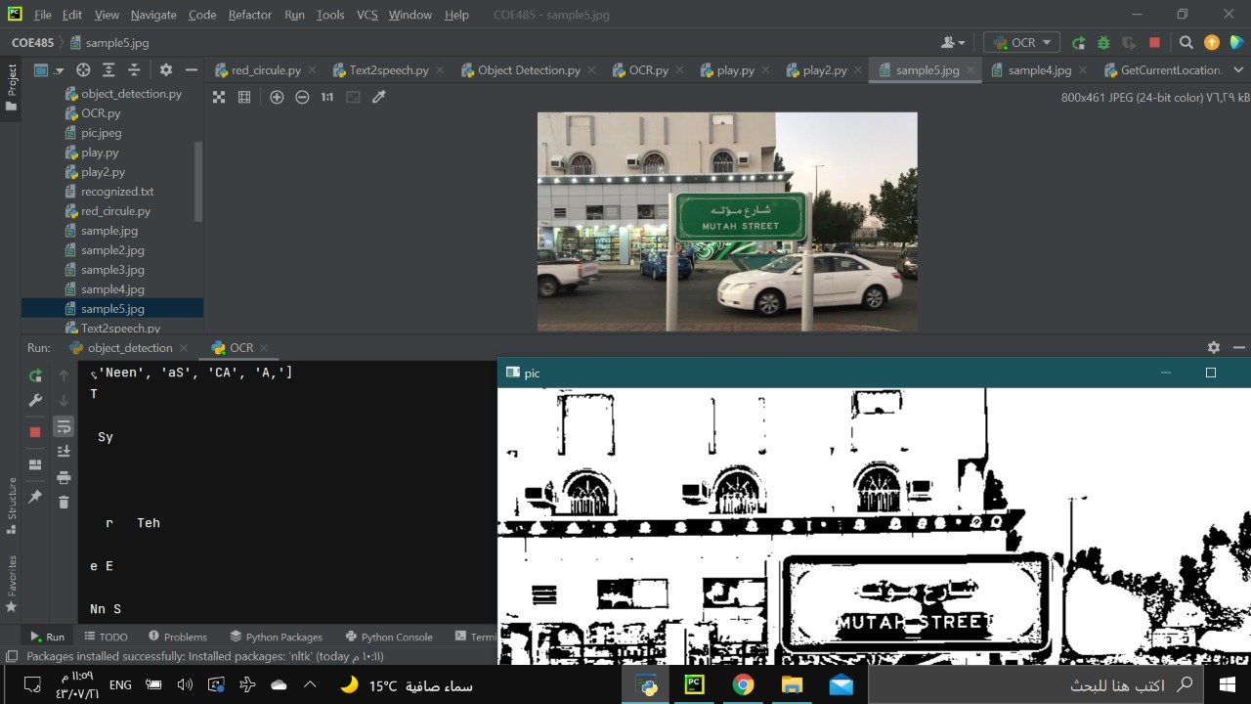

Figure 12 another bad result from OCR model

### 5.1.2. Paddle OCR

Paddle OCR[48] is a powerful toolkit based on series of pre-trained models and it is multi-lingual oriented. It supports multiple languages to detect and suitable for python and available on flutter too. Therefore, it was tested locally, as shown in figure 13, and the results were excellent in detecting texts.

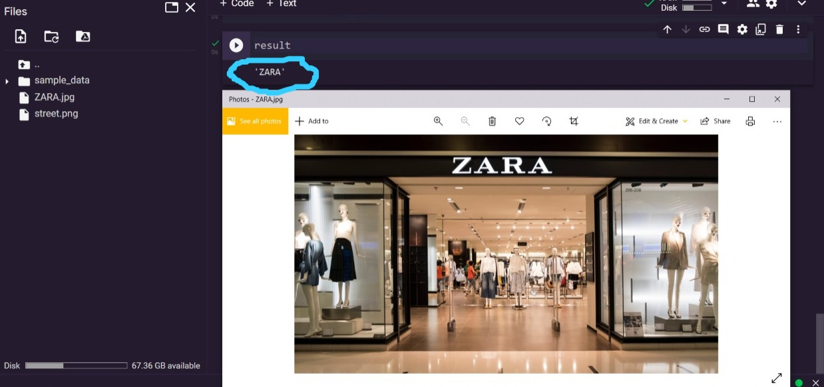

Figure 13 a snapshot of PaddleOCR test

This model was chosen, after testing it locally, to be selected and deployed on AWS cloud. However, trying to deploy the model on AWS has failed with different trials and approaches. Firstly, the model is huge, and Lambda is limited to 512 MB, so image container was the alternative. After that, setting the appropriate Dockerfile & Lambda handler and pushing the image, which takes a lot of time, the image gets an error as shown in figure 14 below.

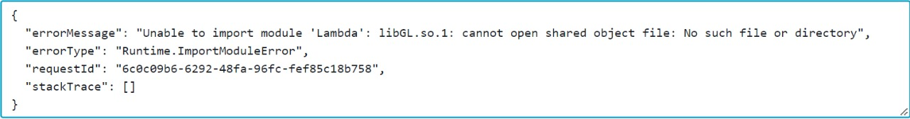

Figure 14 error repeatedly faces in deploying paddleOCR

The previous error, unfortunately, was faced repeatedly and couldn’t be solved. After searching about the problem and trying to solve it, then a dockerfile founded in appendix 2 published in Github was used and tested but the pushing of the image takes long time and eventually the image was bigger than 10 GB. At that time, the team searched for another alternative model, and this was Amazon Recoknition which replaced PaddleOCR. However, python code of paddleocr can be found in appendix 2 also.

Also importing PaddleOCR using the Chaquopy Python SDK, which will be mentioned on 5.3.1, gives an error that cannot be solved which prevents using the library as shown in Figure 15.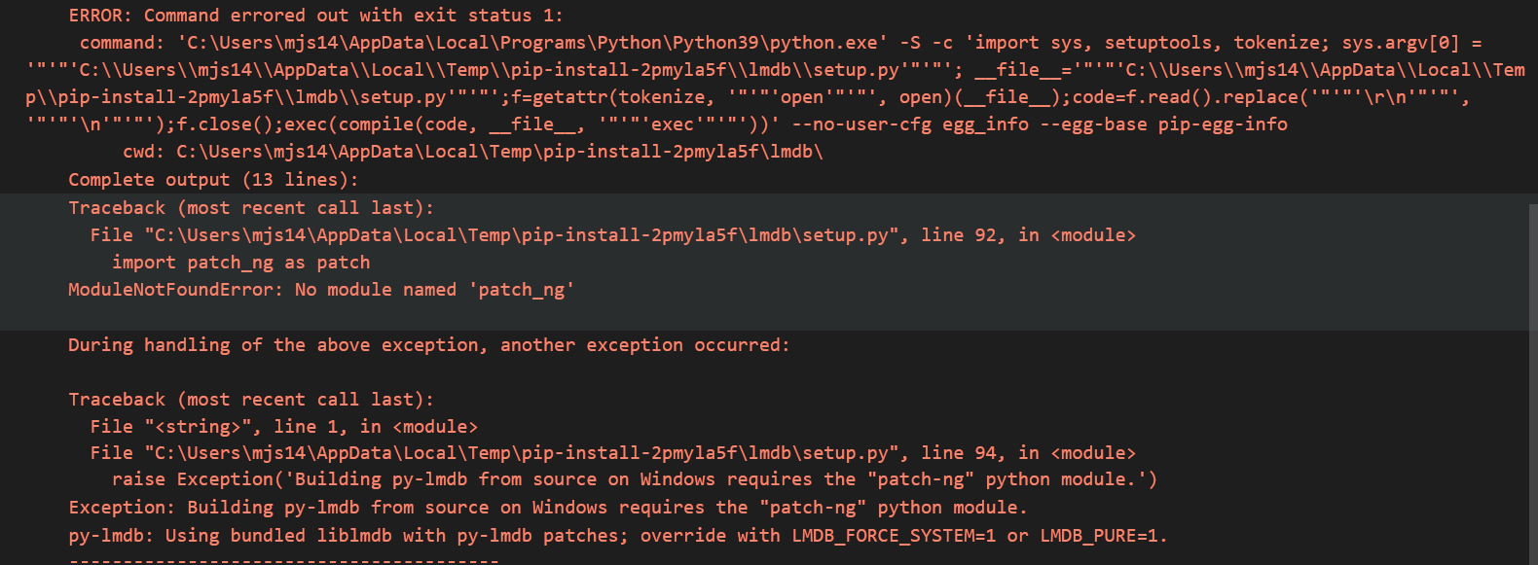

Figure 15 an Error occurs when paddleocr is being installed

### 5.1.3. Amazon Rekognition(selected)

Amazon Rekognition is a deep learning cloud based that have multiple services such as facial recognition, image classification, object detection, and text recognition [45]. It is based on pre-trained models and has been established since 2016 and continued developing their models [45]. In addition, it is suitable, easy to invoke, and suitable for AWS usage since it processes only images and videos which stored in Amazon S3 bucket. Therefore, it was suitable for the project purpose and the best approach to use it is to retrieve stored images in S3 bucket using lambda and perform the text recognition to return the results back. Figure 16, below, shows a python code written in Rekognition documents to be deployed in Lambda function.

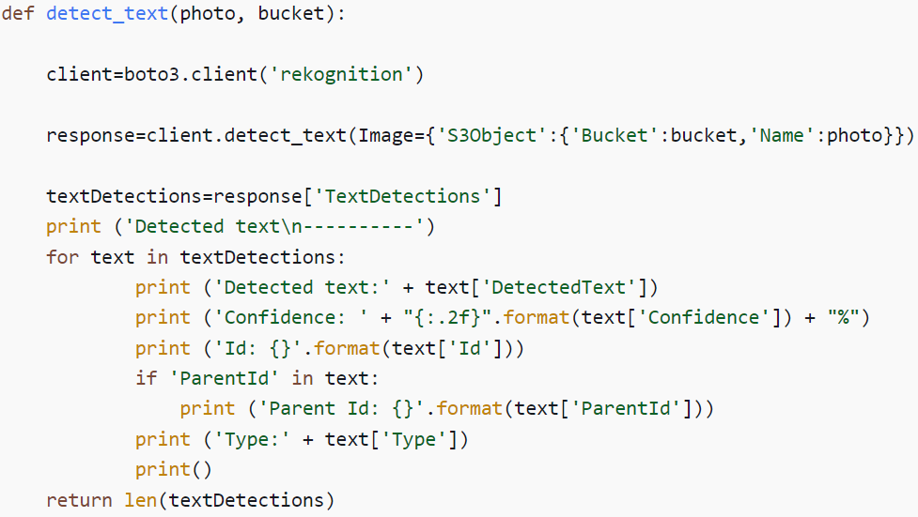

Figure 16 python code of text recognition using Amazon recognition

After that, the code was modified and deployed on AWS Lambda such that Lambda receives an image via API gateway and stores it in S3 bucket, and then it retrieves the image from S3 bucket to invoke Rekognition detect_text function which takes only file from S3 buckets. Finally, after processing the image and getting the result out of it, then there is no need for the photo, and it gets deleted right away. The result of testing is shown in figure 17 below and the modified code can be found in appendix 2.

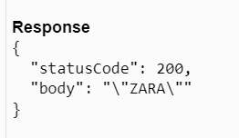

Figure 17 Testing the model deployed on lambda

## 5.2 Traffic light status detection model

There are two candidate models that were modified and tested and one of them was selected. The first one is multiple colour detection, which was rejected, and the other selected one is colour circle detection. The following two parts show the details of both models and why colour circle detection was chosen among them.

### 5.2.1 Multiple Colour Detection

This model, which is published in GeeksforGeeks [46], is meant to detect colours for every group of pixels in a frame. In this code the colours were green, red, and blue, but they can be extra or less colours. However, after testing the code it appears that every red, green, and blue piece will be detected, as shown in the figure 18 below, and it is too sensitive to noise. Moreover, the application of detecting a traffic light status is not achieved. Therefore, it comes the idea of focusing on circles only so that anything other than that will be rejected, and this will be solved and discussed in the following part.

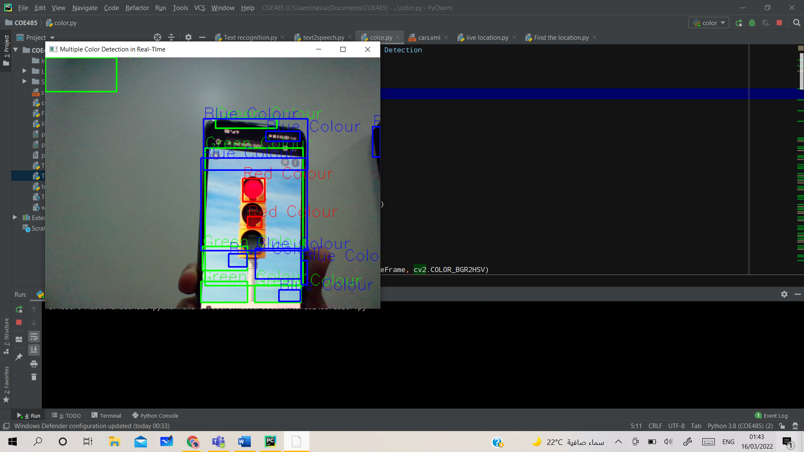

Figure 18, sample test of rejected traffic light status model.

### 5.2.2 Colour circle detection(selected)

There is a selected, modified, and tested model for traffic light status detector. The code [47], originally, was a red circle detector but it can be used to detect a traffic light status and after we applied some customized modification, we made it able to detect green circles also. So, this way the model can detect red circle in a traffic light as stop, and green circle as move. The source of the model is attached in the appendix 2 which contains the modified code. The model described, modified, and tested as follows:

In brief, the code is written in python and utilizes OpenCV library to detect circles. Firstly, the image is blurred to remove noise, and then a red threshold is applied. After that, it detects all circles using Hough transformation function which is available in OpenCV library.

As mentioned before, initially, the model was detecting red circles only. However, it is needed to detect green circles too. There are multiple added lines to the code that enabled it to do such. Firstly, we created a capture frame for green circles like the red capture frame that was written before. As shown below, the difference is the range of colour values which is calculated using [colorizer.org](http://colorizer.org/)



Then, the frame is filtered for green frame same as applied to red one.



After that a Hough transformation is applied to detect the circles in each frame.



Then, it outlines the detected circles, if any, and tells the user to move in case it is green as shown below.





This model was tested, locally, on a pedestrian traffic light for both red & green colours.

Red colour test: As shown below, the colour was detected, and a message is printed on the screen.

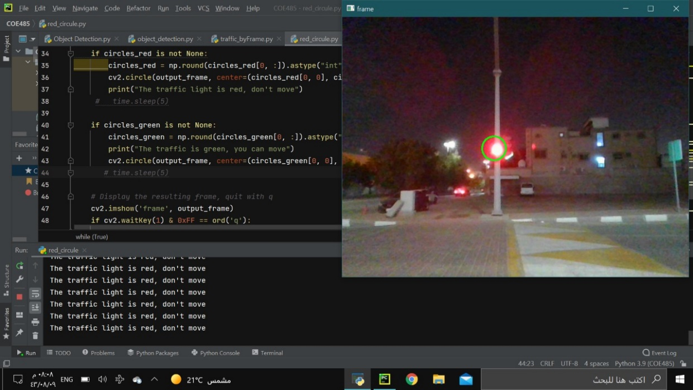

Figure 19, Red color test.

Green colour test: As shown below, the colour was detected, and a message is printed on the screen.

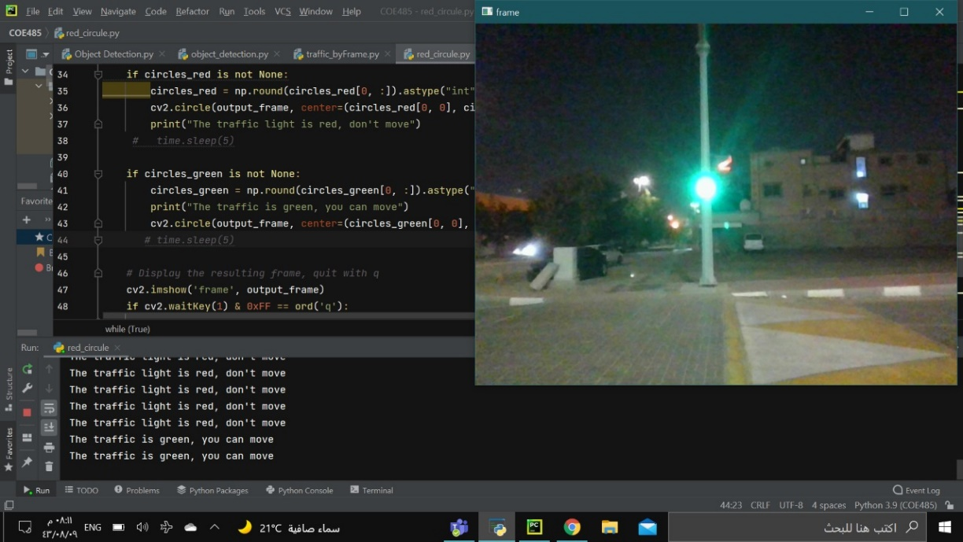

Figure 20 green colour test

Moreover, the distance of the detected colours, both red & yellow, was measured as shown below in Figure 21.

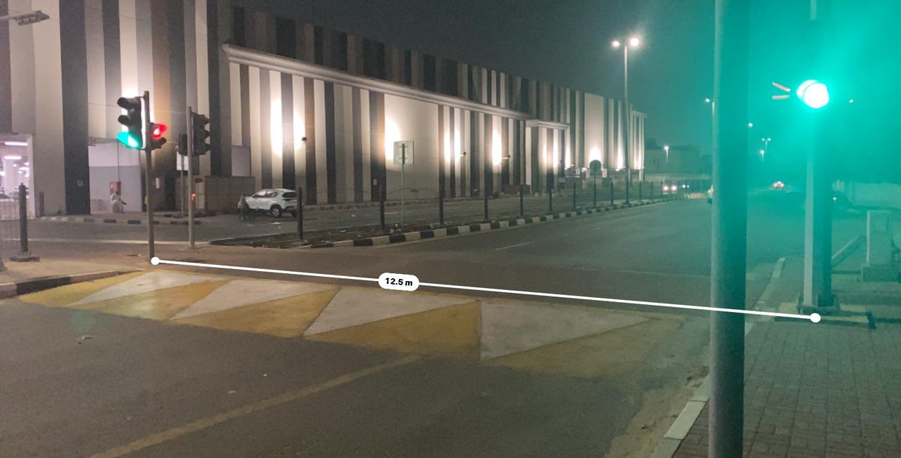

Figure 21 distance of the detected colours

## 5.3 Obstacle detection model

### 5.3.1 Deploying Python solution on phone approach

To detect objects, a pre-trained Deep Neural Networks detection model has been used. That model uses frozen_inference_graph for the weights, and SSD-Mobilenet-v3 for the configuration. That model has a large set of data to detect 91 objects, such as person, traffic light, car, bus, street sign, stop sign, and bunch of other objects. If the model is given a frame of a video stream of frames, it will take that frame as shown in figure 22, process it, and will output a processed frame with what it detected as shown in figure 23.

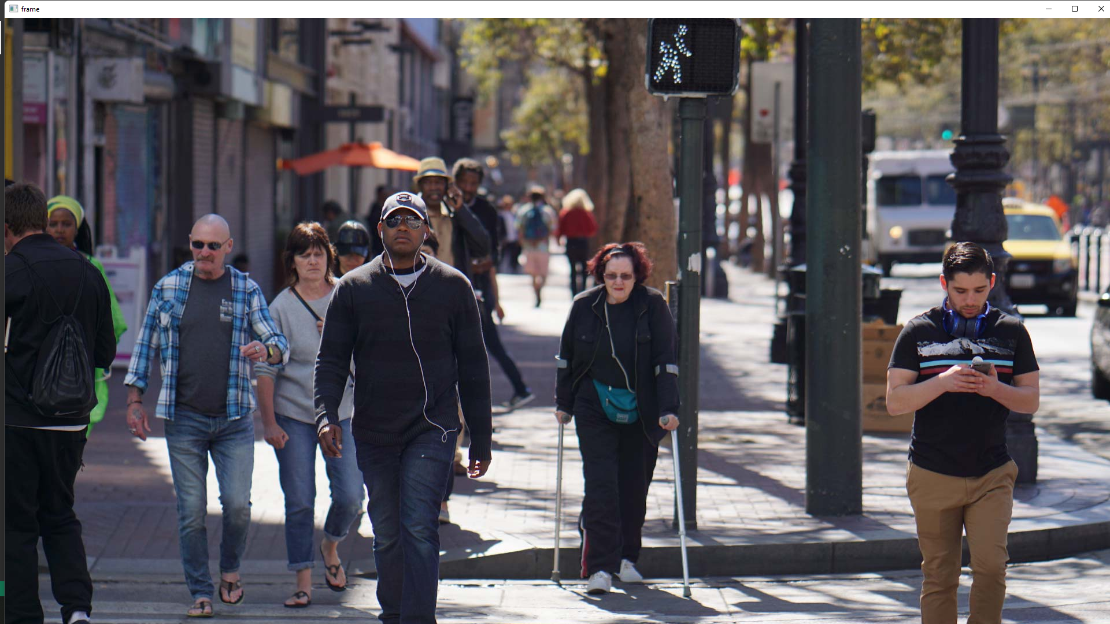

Figure 22: An Input Frame.

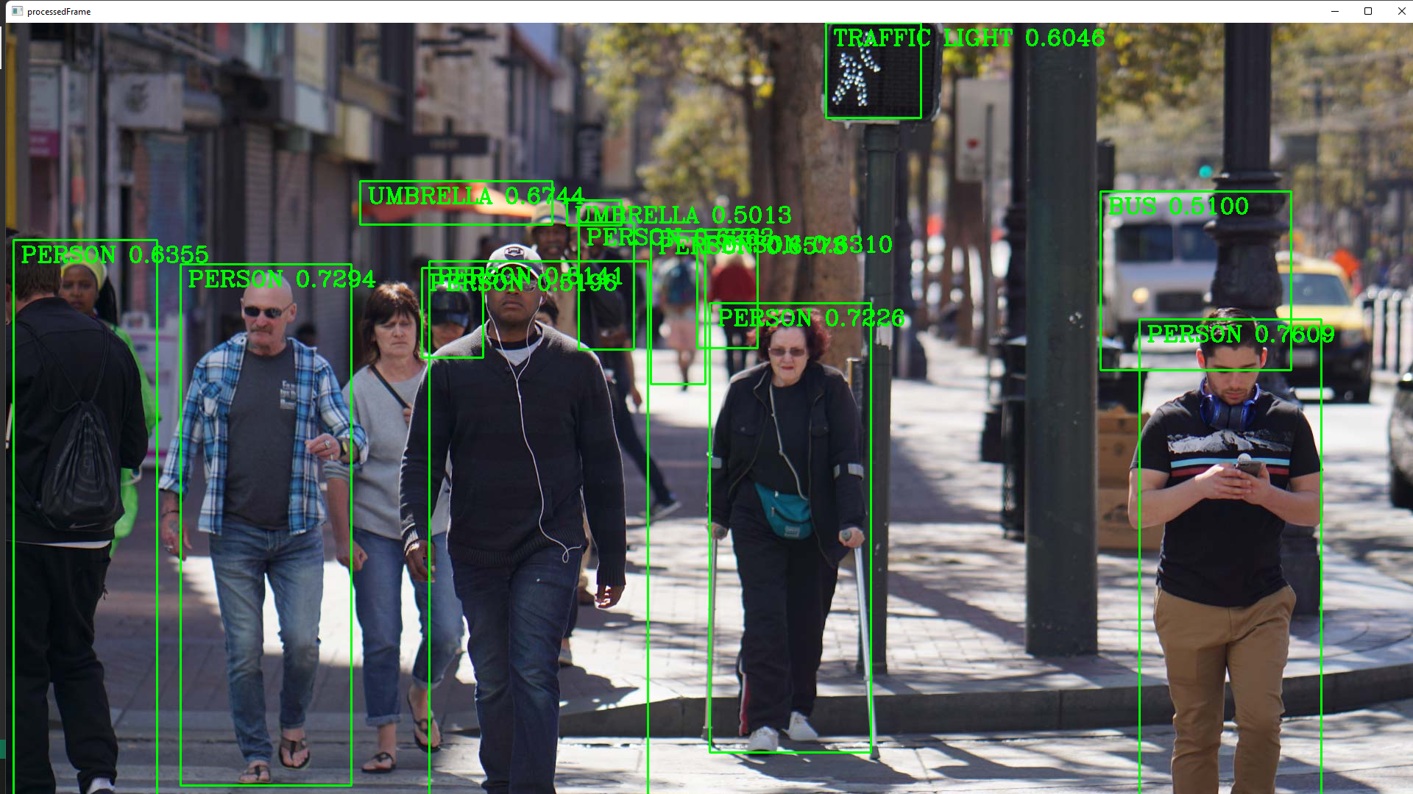

Figure 23: A Processed Frame.

The programming language used for implementing the AI model is Python where OpenCV library was used to do most of the heavy work. The code used can be found in appendix 8.

The code is mainly divided into 3 parts:

1. Setup.
2. Frame process.
3. Output.
4. Setup

The threshold is set for the detection model. It basically means that a model will be detected and shown if and only the model is thrs% confident about it.

The names class are the names from the file coco.names which contains the names of the 91 objects.

To setup the network of the model, the path for the weight and the configure files should be given to the net, as well as setting the input size, scale, mean, and swapRB parameters. Those parameters should be fixed based on the model that is being used and changing one parameter will cause it either not to function properly or report an error.

The video is captured by passing the path of the video or passing 0 which is the index for the camera input which is broken into frames.

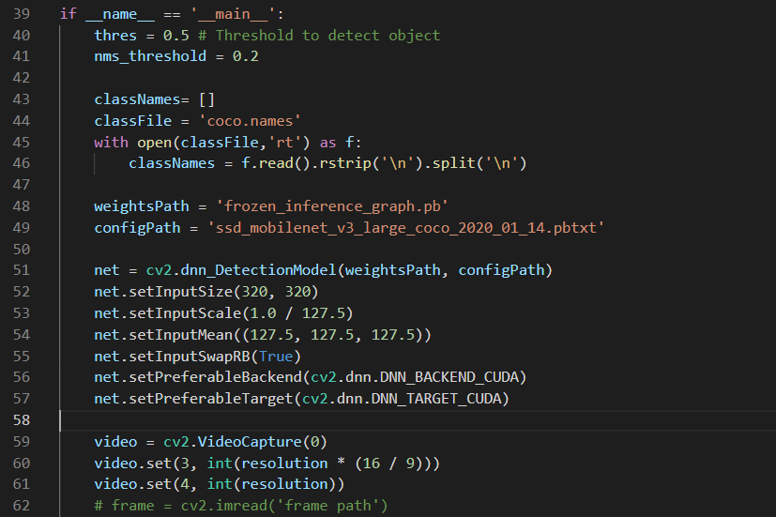

1. Frame process

The previously defined setup is passed for each frame where that frame is copied not to ruin the original frame. Then the net detects the objects in that frame, draws a rectangle on the detected objects, and puts the corresponding class name and how confident it is about it in each frame. Then it returns the processed frame.

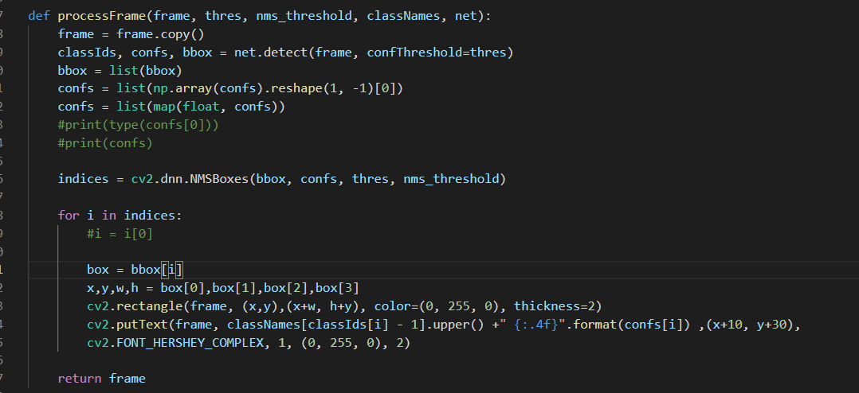

1. Result output

The video is split into frames inside of the loop where each frame calls the process frame function and gets displayed to the user. The loop can be terminated by pressing ‘q’.

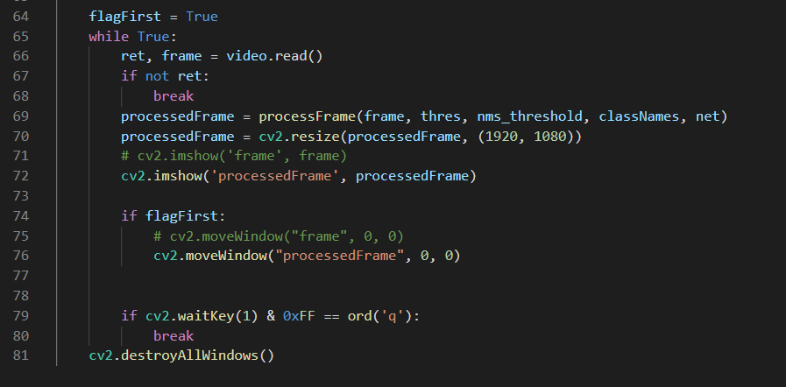

To deploy the Python code into the mobile phone, a library called Chaquopy has been used. Chaquopy is a Python Android SDK used to integrate Python components into an Android app, which uses a vast selection of third-party Python packages, such as SciPy, OpenCV, TensorFlow and many more.

The setup to get the Chaquopy SDK into an Android project is to:

1. Add this line of code ( maven { url "https://chaquo.com/maven" } ) in the repository handler inside the the settings.gradle file.

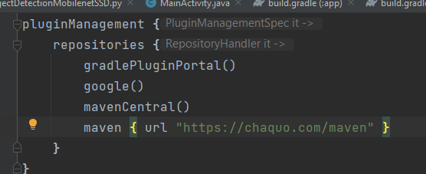

1. Copy this code ( id 'com.chaquo.python' version '11.0.0' apply false ) in the plugins handler in the top-level build.gradle file.

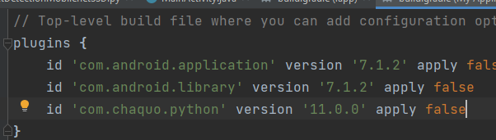

1. Copy these two lines of code (id 'com.android.application' id 'com.chaquo.python' ) in the plugins handler in app-level build file. 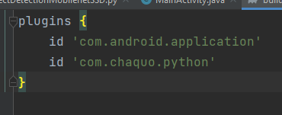
2. Finally sync the Gradle files using Android Studio and under File then Sync Project with Gradle Files.

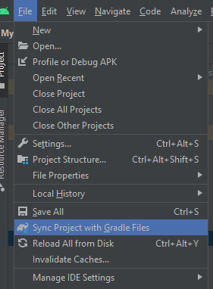

This will make a Python directory where all the Python source codes can be stored.

After the Setup is done some configurations need to be done at the app-level build.gradle file under the defaultConfig handler: The path of the Python interpreter, and the libraries to be installed under python handler, and the abiFilters under ndk handler.

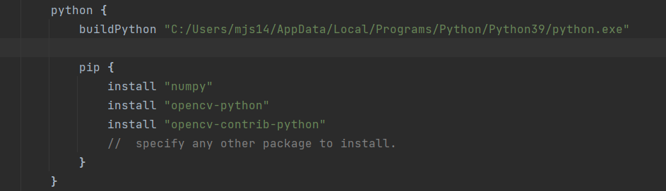

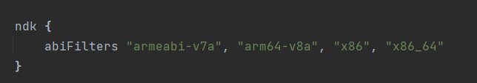

Because the Python interpreter is a native component, you must define which ABIs you want the app to support using the abiFilters parameter. The ABIs that are currently available include:

1. armeabi-v7a, supported by virtually all Android devices.
2. arm64-v8a, supported by most recent Android devices.
3. x86, for the Android emulator.
4. x86_64, for the Android emulator.

After doing another sync, Python codes are ready to be integrated into Android devices.

Chaquopy Java API include useful classes:

1. Python.start(): a static method that start Python if it is not started.

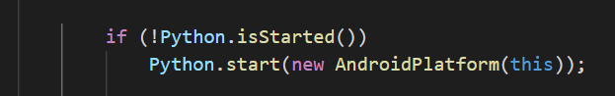

1. Python.getInctance(): it returns the Python instance of type Python.

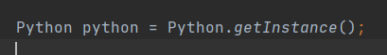

1. getModule(): is used to call a Python module by its file name and returns an object of type PyObject.



1. callAttr(): is used to call the Python functions and and returns the value in a PyObject.



The reasons why using Chaquopy is detrimental:

1. The very low effeciency to use it and integrate in Flutter:

To integrate it into Flutter, the function needs to be called from 3 different languages, Python needs to be called from Java which is called from Dart.

1. Lack of ability of using using Dart UI:

Using Java on Flutter will override the application to run on Java, which will use xml UI layout.

1. The size getting very large:

To make Python compatible with the application, the abiFilter is used whose size is very large.

1. The availability of other approaches:

The object detection can be deployed using flutter, and the traffic light color detection can be deployed using the cloud.

1. Requirement of license:

The application will turn off after some time because the library needs to be licensed.

### 5.3.2 Deploying native flutter solution on the phone (selected)

For the object detection, a “TensorFlow lite” pre-trained model is utilized which could be found in appendix 1. The selected model can detect a thousand different objects. Additionally, the code is primarily taken from appendix 1, with modifications, primarily to parameters such as the number of objects to detect. The model would normally detect multiple objects, but the code has been configured to only output the object detected with the most confidence according to the model. Figure 24 shows four objects being identified in an outdoor environment, where the number shown next to the object name represents the confidence.

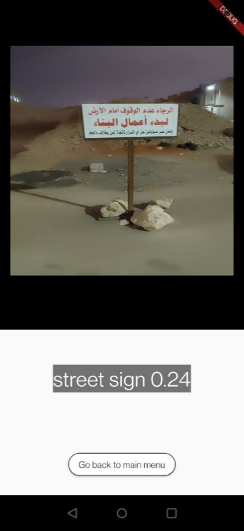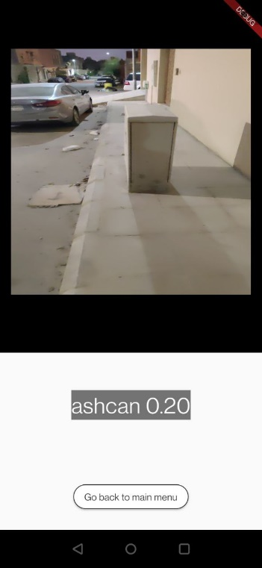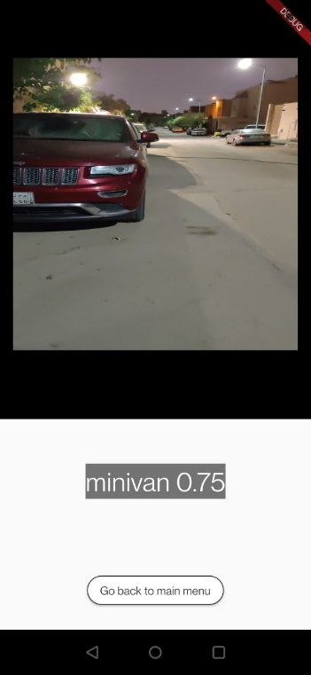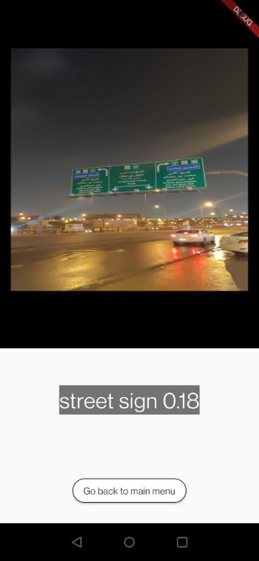

Figure 24, object detection sample test.

The list of thousand objects that the model was trained to detect given in appendix 1 was streamlined to five possible outputs, this is done to give a better experience for the user and not overcomplicate the text to speech integration. The actual objects and what the program would output are highlighted in Table 12.

**Table 12, categorization of objects' detection process.**

|  |  |
| --- | --- |
| Object | Category |
| ambulance  cab  freight car  jeep  minibus  minivan  racer  sports car  streetcar | Car |
| traffic light | Traffic light |
| street sign  scoreboard | Street sign |
| barrel  carton  crate  park bench  rain barrel  stone wall  worm fence  turnstile  punching bag  pole  manhole cover  ashcan  bucket  barrow | Obstacle |
| sliding door | Door |

It is imperative to clarify that the categorization elicitation highlighted in Table 12, is the result of manual outdoor testing both at night and in day environments. It was observed from testing that some desired objects were miscategorized. As such, street signs would be recognized as scoreboards, and punching bag would actually be a pole on the street, which is why it is categorized as obstacle in Table 12. The slight mis-categorization is not exclusive to one label in specific, that is why some Objects in Table 12 might seem out of place.

The accuracy, specifically for the traffic light was much better at day. At night, it was observed that there are often too many false positives labeling the result as traffic light as can be seen in figure 25, showing two results within a few seconds.

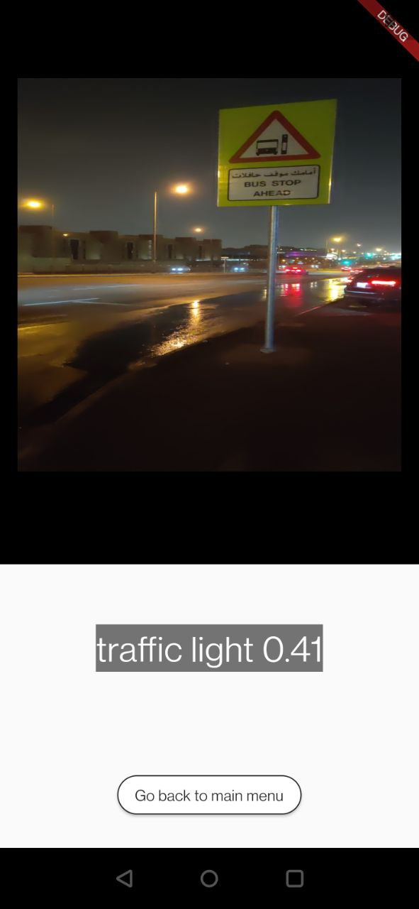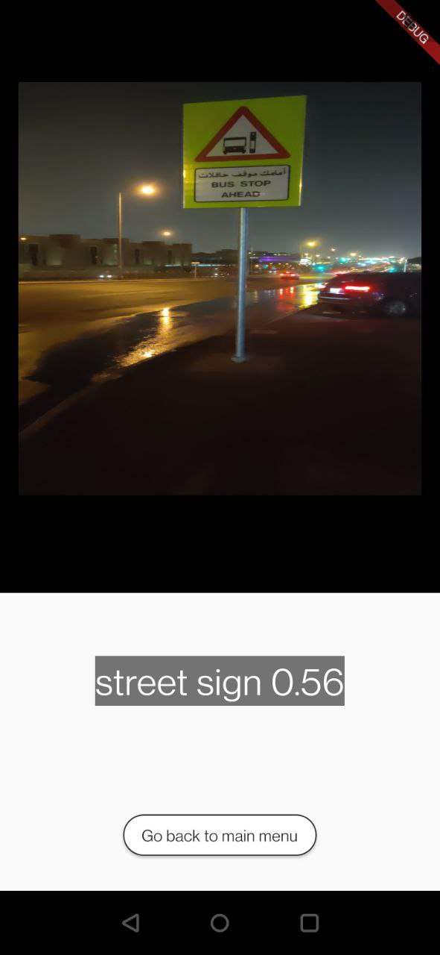

Figure 25, inconsistency and mis-categorization of traffic lights at night.

The model utilized takes the direct camera stream feed as input, but only analyzes individual frames in byte format. Furthermore, the objects detected are often from a distance of around 1 to 2 meters.

## 5.4 Text to speech convertor

In the beginning, it was decided to convert the text, which is the instruction or text that is returned from cloud, in cloud and play the audio file only on the phone. However, an audio file size is quite bigger than a text file size, and hence transmitting a text file from cloud will utilize the throughput and bandwidth more than transmitting an audio file. As a result, text to speech convertor component was moved into mobile user.

Figure 26 shown below illustrates the difference between a text file and an audio file in terms of size where both files contain the same string. As seen, the audio file size is almost 1000 times the text file size. Thus, transmitting the text file is much efficient, and hence the text to speech convertor will be running on the mobile user.

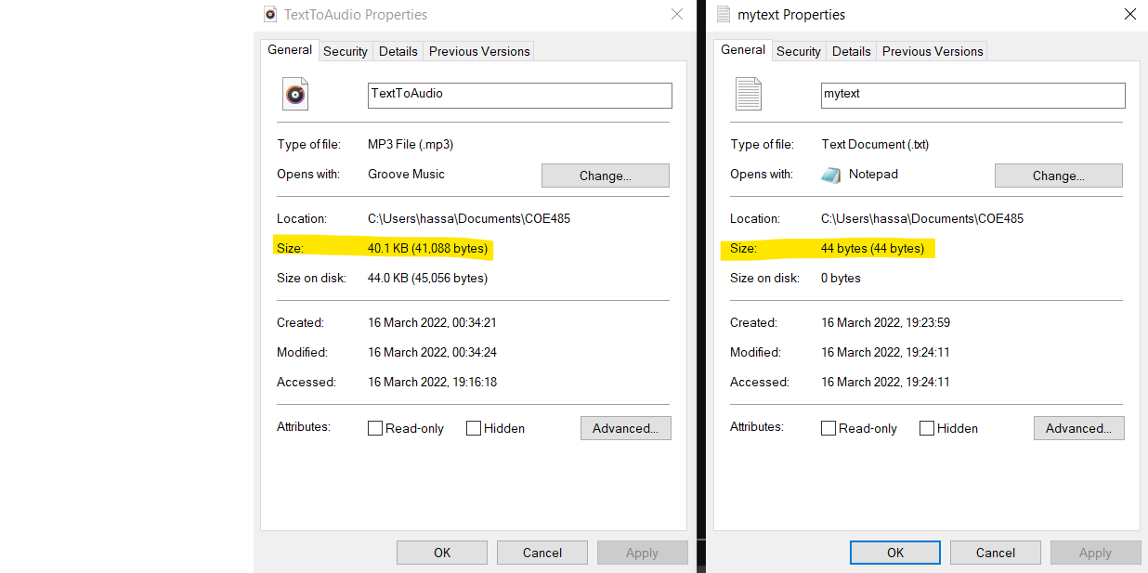

Figure 26 a comparison between text file and audio file size

### 5.4.1 Python TTS

Text to speech conversion is available in python using Google Text to Speech (gTTS) library[49]. This library is suitable, it just receives a text and converts it to speech file. There are some additional features such as languages list and various accents, etc.

Below is shown the python code which was selected and tested on a local machine. The Test was done for both Arabic and English languages where Arabic code is *ar* and English code is *en*. Also, there is a parameter called slow that controls the speed of the generated speech. The source code is attached in the appendix 2, and the code was not modified.

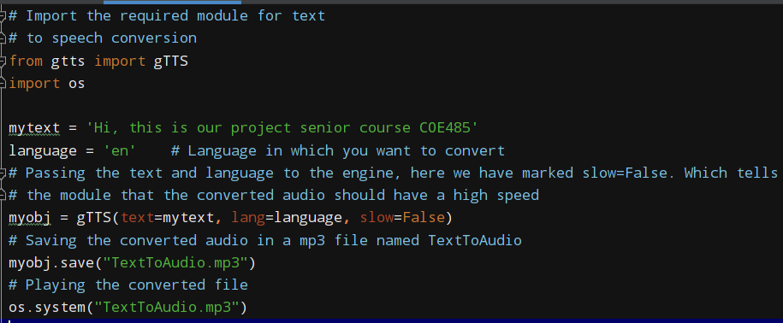

Figure 27, sample of Python TTS code.

### 5.4.2 Flutter TTS (Selected)

Text to speech convertor, as stated in deployment diagram, will be running on mobile user node and its implementation will be on a flutter application. Therefore, the most obvious choice is to use flutter the TTS package "flutter_tts” since the project is primarily developed with the Flutter framework. The code for TTS in Flutter only requires a string as input and would output speech on the phone. TTS allows for some customization to the voice, how high its pitch is, and the speed in which the voice would go.

The TTS has been utilized not only to inform the user of the output, but it also informs them whenever they enter a certain mode. The application would say "You are now in mode X" whenever the user selects one of the modes, to help them navigate through the process easier. For the object detection mode, the column “category” shown in Table 12 is what the TTS would output to the user, and not the object that was detected necessarily.

## 5.5 Mobile camera interface

As stated before, the system needs to get a photo from a camera feed every 5 seconds and send it to the cloud. After that the phone will receive the response as text. The text will be converted into audio speech by the TTS. There are some modifications to the code models that were taken from Flutter documentation. For instance, there were camera button was removed because the system captures automatically the camera feed every 5 seconds. The HTTP request utilized to post the image is “post” method. These models utilize the traffic light status model and the OCR model. The code is developed in Flutter framework.

## 5.6 Database

Google Firebase and Firestore where primarily chosen to accelerate the development time of the project. Firstly, Firebase has great support in Flutter which is the framework that was chosen to develop the project in. Furthermore, Firestore utilizes a NoSQL scheme, which is suitable for developers with minimal experience in databases, where records and parameters are flexible in comparison to MySQL databases [36]. Moreover, the usage of a database not within the parameters of AWS allows for more independent parallel development of the project in different stages. Additionally, Firebase is a free of cost solution, at least for the project’s scale.

### 5.6.1 User credential management

Google Firebase offers numerous great features that are related to the user enrolment mechanism. Firebase offers third-party sign in, forgot password mechanisms, and email two factor authentication, while having great up to date support plugins for Flutter, such as “firebase_core” and “firebase_auth”.

For the project, the enrolment process is shared by the blind user and their caretaker, where only the user email, caretaker email and password are required as credentials. Upon enrolment and email verification, a record for the blind user is initiated in the Firestore database as can be observed from figure 28.

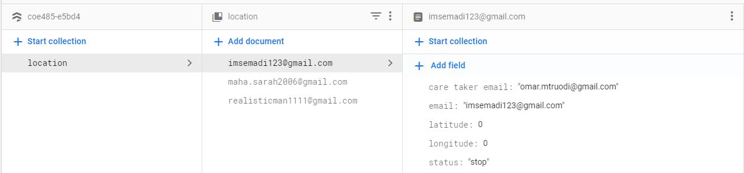

Figure 28, user record initialization.

Additionally, since google authentication is utilized for signing up and signing in, an authentication dashboard in Firebase is maintained to keep track of users enrolled in the database, as can be seen in figure 29.

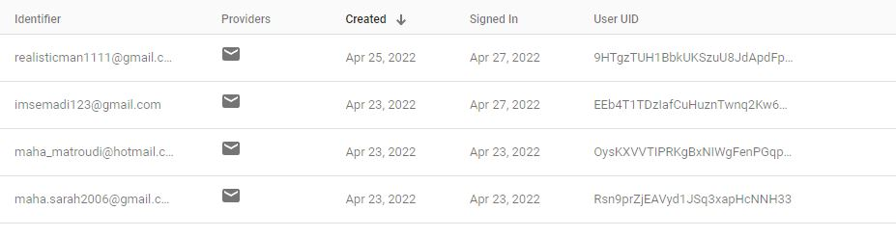

Figure 29, user’s credentials dashboard in firebase.

Initially the application had a feature to sign in using Google account, but it was scrapped because it hindered performance, and did not allow for sign out if the session is disconnected.

For the enrolment program, Multiple codes were combined and modified, and they could be found in the appendix 1.

### 5.6.2 User's live location

For the live location component, the way it is constructed is that the flutter application utilized by the blind user would obtain their current longitude and latitude using a flutter package named “location”. After obtaining the necessary parameters, the blind user’s phone posts them every two seconds to their record in the database, which the caretaker can access, within Firebase’s Firestore. Furthermore, on the caretaker’s side, the application utilizes google maps API which is tied with this specific project from google cloud to display the map visually using google maps.

For the caretaker to start or stop tracking the blind user’s location, a page has been designed in which they would provide their email. After providing the caretaker’s email address, every blind user that has them as their caretaker would appear as can be seen in figure 30, and the caretaker could issue a command to either start or stop collecting a specific blind user’s location.

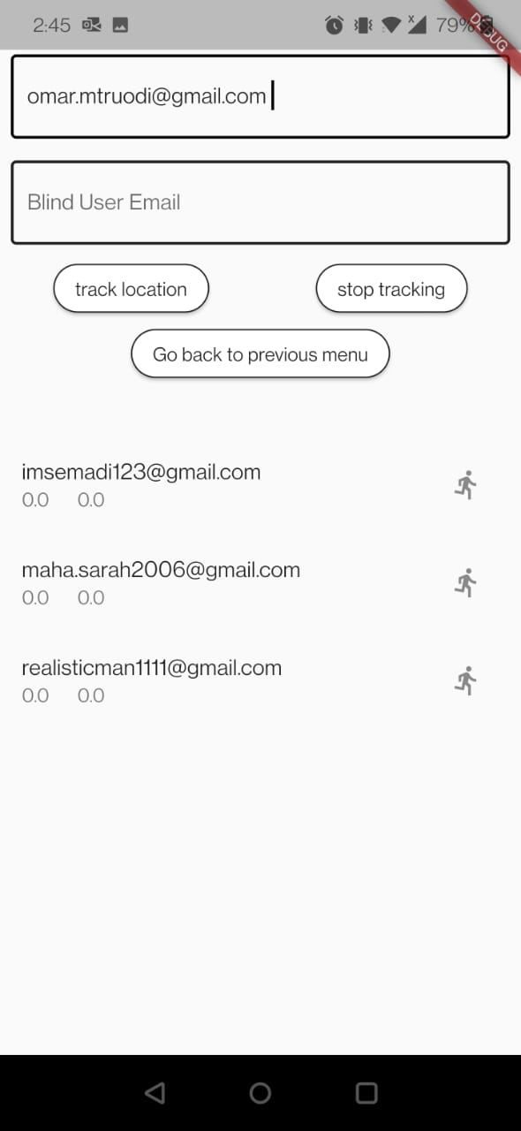

Figure 30, caretaker page.

When a caretaker specifies the blind user’s email address and click on either the “track location” or “stop location” buttons, the parameter by the name “status” would be modified to inform the blind user’s application. On the other hand, a stream listener has been configured on the blind user’s side to inform them only if the “status” parameter within their record has been modified.

It is imperative that the distinction between simple CRUD (create, read, update, delete) and steam listeners in Firestore is clear. CRUD operations must be called explicitly within the code, such as in Get or Post HTTP requests [37]. On the other hand, streams are set up to monitor a specific record or entire collections and would reactively return a value only when any parameter within the record is altered [38]. Streams are preferred in real-time applications such as this project [38].

For the project’s case, once the blind user signs in, their email is passed to the next screen which has the listener stream embedded in it. The blind user’ application would use their email as the primary key for the database to start listening to the “status” parameter within their record, as can be seen in figure 31.

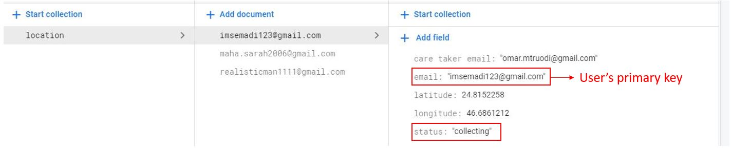

Figure 31, parameters observed by the user's application.

Similarly, the caretaker would utilize their “care taker email” parameter which could potentially repeat on multiple records, to listen through a stream to the continuous change in longitude and latitude, as can be observed in figure 32.

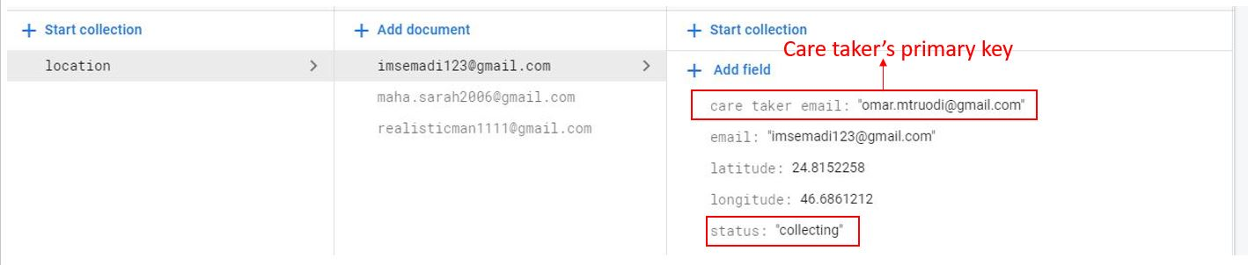

Figure 32, parameters observed by caretaker's application.

The “status” field could be in four different states, “collect”, “collecting”, “stop”, and “stopped”. The reason as to why they were not limited to only two, to either collect or stop is because the methods that are called within the program are set up in a way in which they should only be called once. As such, if the stream observes that the status is “collect” it will call the function to collect the location, if the status is not changed to “collecting”, the method will be called again and again, until it results in an unstable build and potentially crash the whole application.

While collecting the location of the user, the caretaker would get a direct feed showing the longitude and latitude of the specified user, as can be seen in figure 33.

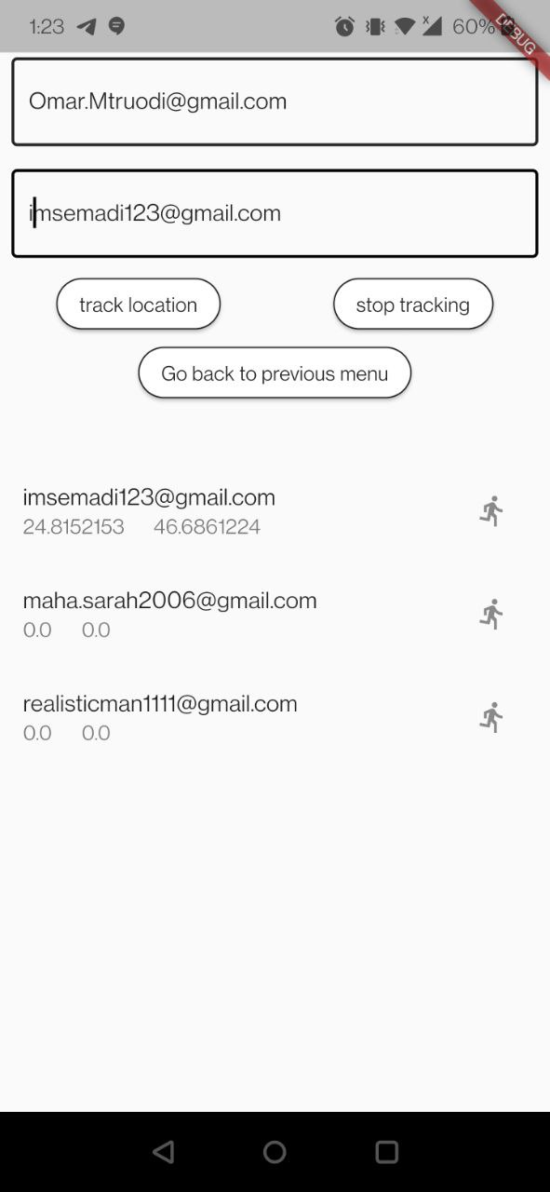

Figure 33, caretaker's page while collecting the location.

Additionally, if the caretaker desires to get a live location via map, they could click on the symbol on the right showing a walking person in figure 33, after that the map would show the blind user’s location as can be observed in Figure 34 below.

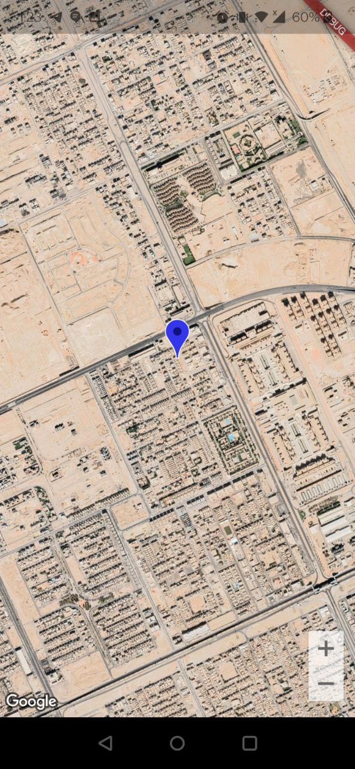

Figure 34, map view of user's live location.

The base code for the live location tracker was prewritten, but it was quite heavily modified to fit what was needed for the project, and it can be seen in the appendix 1.

## 5.7 Cloud computing

As indicated by figure 7, the project is to deploy two AI components in AWS. AWS was chosen because it is the most popular and mostly used cloud provider in the market, where it offers more than 200 different services [24][25]. AWS has multiple excellent services that are specifically designed to train and deploy AI models, such as “SageMaker”, and “Rekognition”.

### 5.7.1 How to deploy AI models on cloud

There are multiple approaches that can be used to deploy AI model, or any computing code, on AWS. However, it depends on the model to deployed, which libraries will be utilized, what is type of packages it needs to run, and how fast it should be. There are multiple approaches that have been tested. The following subsections will discuss each method and show which one was chosen and why.

#### 5.7.1.1 SageMaker(rejected)

Unfortunately, SageMaker is not suitable for the project’s scope, since model training would not be needed, it also is quite costly, with a free tier that lasts for short time [26]. However, since SageMaker provides an access to Jupyter notebook and initiating notebook instances, it was suitable for installing huge libraries such as PaddleOCR using the command pip install. Therefore, there was a try to deploy PaddleOCR using SageMaker but eventually, for some reason, it shows a message says “Kernel is dead”, as shown in figure 35 and this error couldn’t be resolved so this approach was rejected.

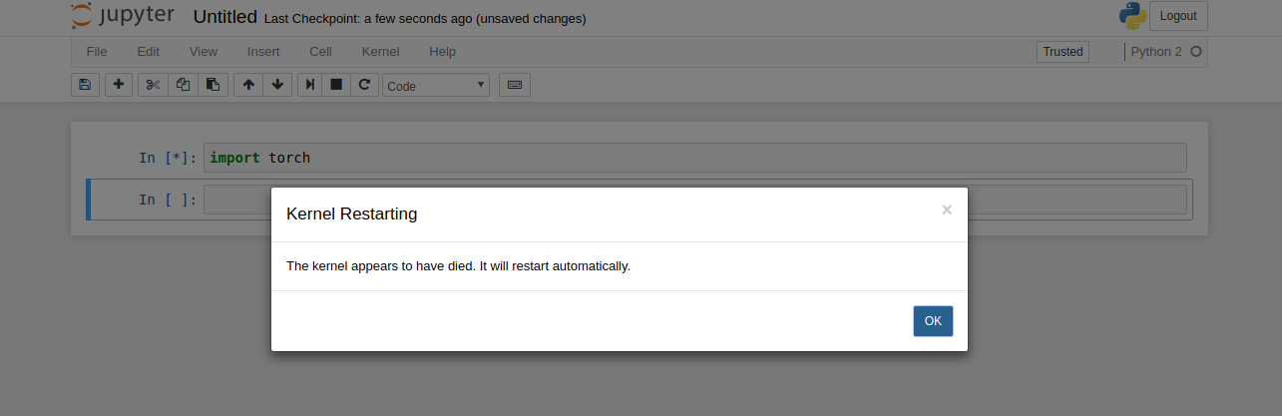

Figure 35 error raised during running paddleOCR

#### 5.7.1.2 Serverless Lambda

Since the goal is to deploy an AI model onto AWS for free, the approach in Figure 36, is great one, which employs a serverless structure, where the Lambda function only executes its code per event [27].

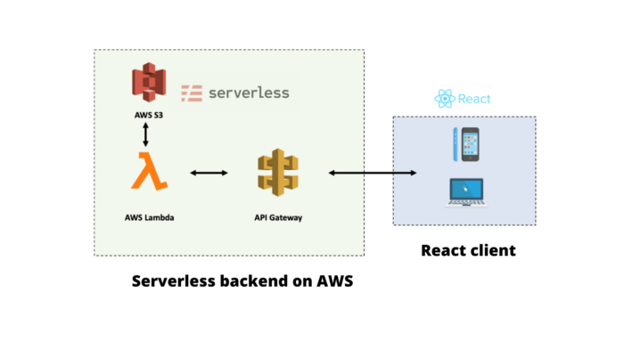

Figure 36, potential architecture to be adopted in AWS for the project [27].

The way the architecture in figure 36 would operate is as follows: The mobile would send an image using a RESTful command to the API, then the API would trigger the Lambda function which would then fetch a pretrained model from the S3 bucket and then execute the necessary code [27]. It must be stated that the architecture in figure 36, might not fully reflect the project, where the project would utilize Flutter instead of React. Additionally, the framework Serverless might be utilized within the AWS’ area, which would help in deploying services, and entire infrastructure from a single command line interface (CLI) [28].

However, there are a couple of trade-offs that must be realised when opting to minimize the cost in AWS. Firstly, the S3 service allows for only 5GB of free storage, which would not be able to contain many models [29]. Additionally, S3 is considered one of slowest options for storing data within AWS [30]. Furthermore, perhaps the most curtail in computing everything in the Lambda function would be the fact that it is limited to only 512 MB in memory, meaning that necessary libraries could not be imported [39].

#### 5.7.1.3 AWS Amplify(rejected)

Another possible approach would have been to utilize the service AWS Amplify, which takes more of a high-level approach. Amplify determines the users’ needs and utilizes other services in the background to meet them [32]. Amplify is also configured to run with many frameworks, such as React and Flutter [31]. As expected, the ease of usability offered by Amplify is met with a substantial financial cost, which makes it unsuitable for the project, unless the scope of what the AWS cloud would do is to be minimized [32].

#### 5.7.1.4 Lambda with container (selected)

Docker is a software platform that enable developers to build their applications in a container that supports all components that a software needs to run such as libraries, tools, etc. Docker, basically, is an operating system for a container that virtualize the operating system server, and this is like the idea of virtual machine that virtualize the server hardware as shown un figure 37 below.

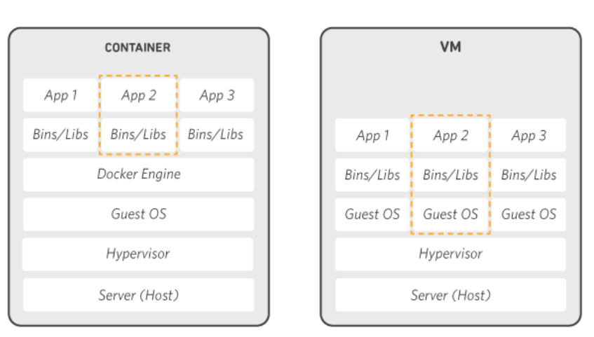

Figure 37 Container vs. virtual machine

So, Docker is installed in each server that hosts containers and then a developer builds container, starts it, or closes it using some commands via AWS CLI. Thus, it is suitable, low-cost, highly reliable, and can install all needed packages.

However, Docker needs to be installed on a local machine as well as AWS CLI. It is needed to build a Docker image which contains all needed instructions to create a container that can run on Docker platform. To do so, it needs a Docker file that contains instructions to build the image along with the needed libraries & packages installed to run whatever the developer wants on the container. As shown in figure 38 below, a Docker file that was used to build the image of traffic light model. The code of Docker file can be found in appendix 2.

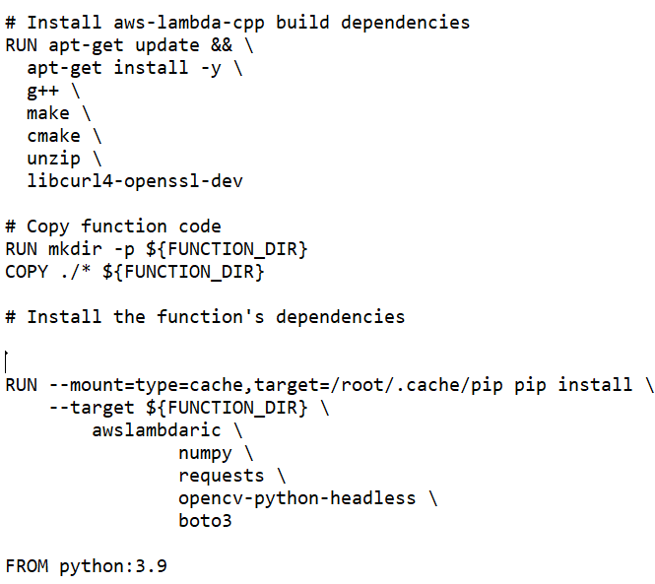

Figure 38 part of Docker file contains instructions to build a Docker image

At the end of the Docker file there exists a command that instructs the image to run which python code to be running when the image is invoked. This python file must exist in the same directory of the Docker file such that it is embedded in the container too. Figure 39 illustrate the idea of using the instructions of Docker file to build a Docker image that will be deployed in a container.

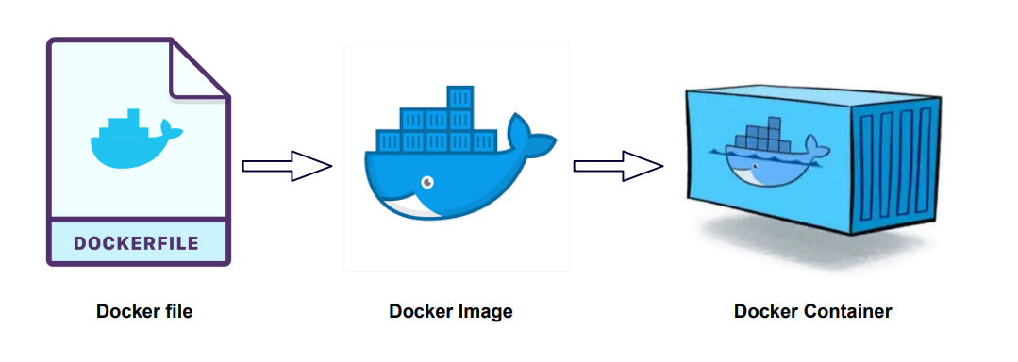

Figure 39 Illustration of Docker file & Docker image and how the image will be deployed in a container

After building the Docker image, then it needs to be deployed in a container that manages and stores the image, and this can be achieved using Amazon Elastic Registry Container (Amazon ECR). After that AWS Lambda is used as a handler where we deploy the image stored in ECR and then Lambda is connected via API gateway to end user who can trigger Lambda function and then Lambda will invoke the python code embedded in the image. As shown below, figure 40 illustrates the idea pushing Docker image into ECR and figure 41 illustrates how the data flows from end till Amazon ECR.

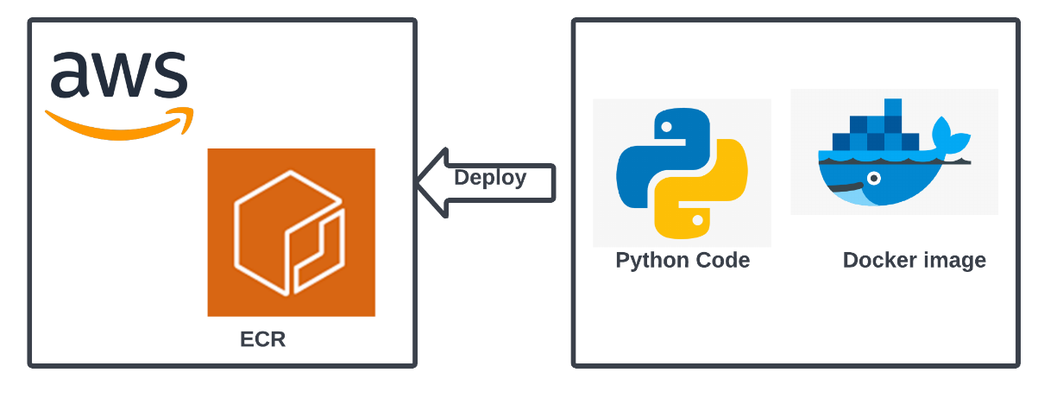

Figure 40 Illustration of pushing Docker image and deploying it on ECR

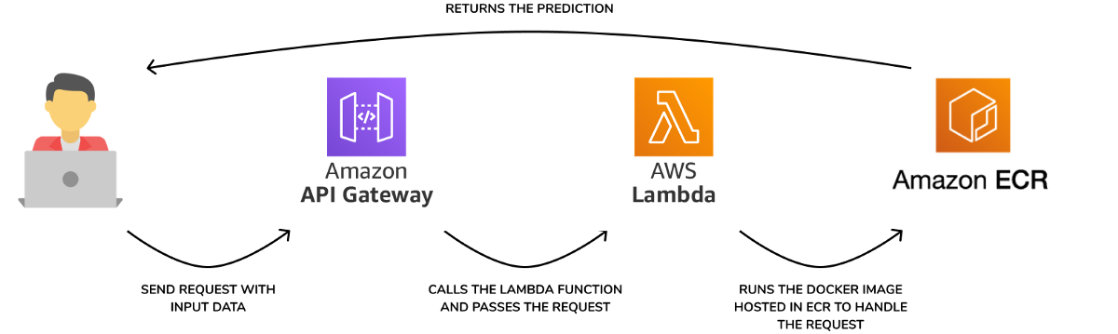

Figure 41 Illustration of the dataflow between the end user and ECR that stores Docker image

#### 5.7.1.5 Rekognition (selected)

The architecture of Amazon Rekognition is simple and suitable, easy to manage, and provided services are highly powerful. Thus, it was a suitable choice to be made after choosing Amazon Rekognition OCR to be used as mentioned before. Amazon Rekognition can process images and videos only contained in the Amazon S3 bucket and this can be achieved using AWS Lambda. Figure 42 below shows the architecture of using Amazon Rekognition.

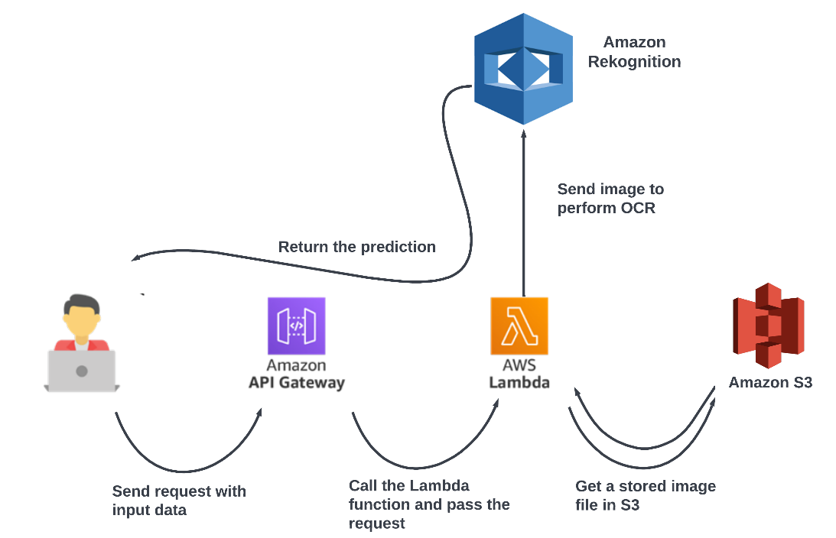

Figure 42 Architecture of using AWS Rekognition

### 5.7.2 Deploying OCR model

As stated before, OCR model was chosen to be Amazon Rekognition text detection and it was mentioned, as shown in figure 7, that it uses Lambda & S3 bucket in order to let Rekognition perform the task. Therefore, a Lambda a function was written with python 3.9 that does the following procedure:

1. Receive 64 encoded image from API gateway.
2. Generate a random number to name the image add contact the extension.

For example, 443223424.jpg

1. Put the image in S3 bucket named “uploadfromapilambda”
2. Invoke text_detection method and tell it to process that specific image in S3 bucket and return the result.
3. Delete the image from S3 bucket to utilize the memory as it is not needed anymore.
4. Return the results back via API gateway.

The result of generating a random number for naming the image is to allow multiuser processing with isolated pictures such that no one overwrites the others. After processing the image, then no need to keep that image and hence it is deleted to utilize S3 memory and not to get crowded or duplicated names occur. A screenshot is shown in figure 43 and the code can be found in appendix 2.

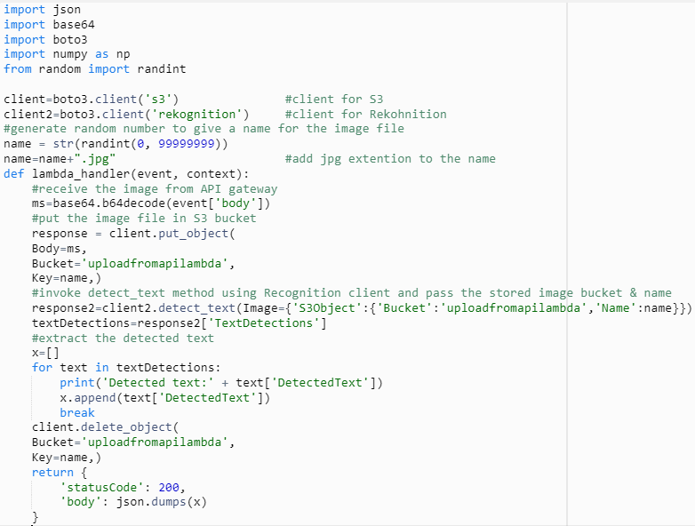

Figure 43 Lambda function for OCR

One final note, to conclude this section, is that Lambda does not support numpy import and it needs to add *AWSDataWrangler-Python39* layer via Lambda configuration to allow that import. This step was done in the configuration step.

### 5.7.3 Deploying traffic light model

First of all, traffic light model is deployed such that a 64-base encoded image is sent to Lambda and then some image processing is done, as explained before, and after that the result will be returned via API gateway. Here S3 will not be used, and no image storing because the model is designed to process the image as soon as it arrives without any unnecessary steps.

Now, deploying traffic light model was based on Docker image approach and this section describes the steps that were taken to deploy the model as follows:

1. Write a Lambda handler, in python 3.9, and embed the model with it as shown in figure 44 below.
2. Open an ECR repository named *senior_design_project.*

This repository will be used to save the image.

1. Prepare a Docker file that contains all instructions to build the image as well as the needed packages & libraries and specify the python version.

In this Docker file, OpenCV & numpy is installed with python 3.9.

1. Put Dockerfile & Lambda.py in one directory.
2. Open Windows PowerShell in a local machine, which has Docker & AWS CLI installed, and follow push commands that found in ECR repository page as shown in figure 45.

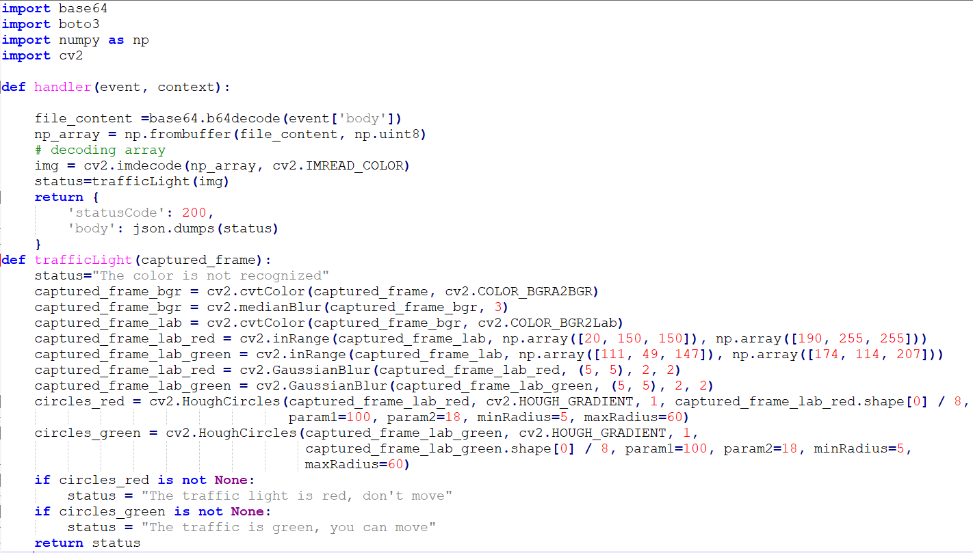

Figure 44 Lambda handler for traffic light model

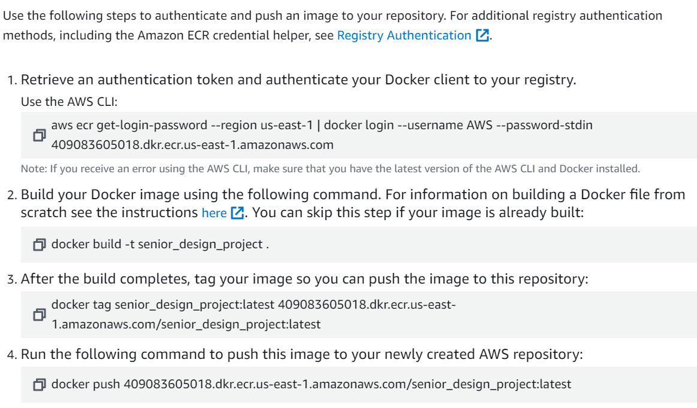

Figure 45 Push command used to push an image to ECR repository

After pushing the image on senior_design_project repository, then this image can be deployed to a Lambda Handler as follows:

1. Create a Lambda function using image *Container image* choice.
2. Choose the image from senior_design_project repository.
3. Create a role that have full access to AWS services.
4. Add a trigger to the function which is a pre-made API gateway (will be discussed in the following subsection).

Now, the image is deployed to a lambda handler and have an endpoint that can be used to make a request to it.

Docker file, Lambda handler code, can be found in appendix 2.

### 5.7.4 API gateway

API gateway is created using HTTP API, it is cost effective and supports Lambda. Firstly, HTTP is selected, a name for the API, then routes & stages are configured (an HTTP method and a resource path), and finally the invoke URL will be created as follows <https://b2gbayr00m.execute-api.us-east-1.amazonaws.com>. After that, a function is created, and a trigger is added to the function as shown below in figure 46 to be an API gateway and this will be chosen to be the one that was created before.

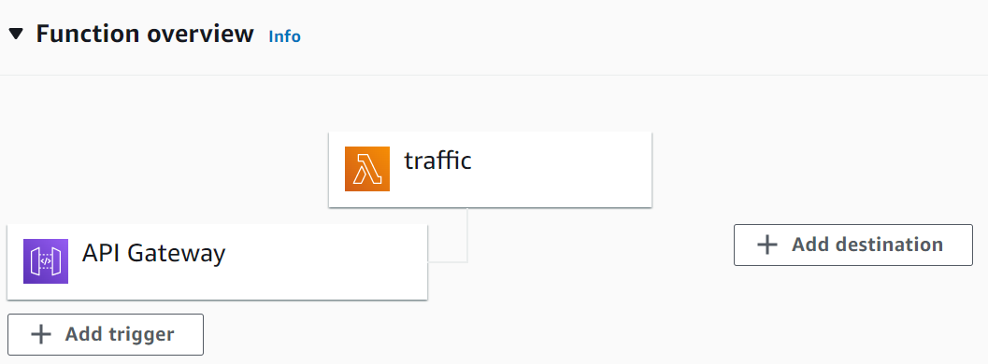

Figure 46 Lambda function trigger added as an API gateway

After that the function trigger will show up with an API endpoint, shown in figure 47, to be used in the user end device to make a request.

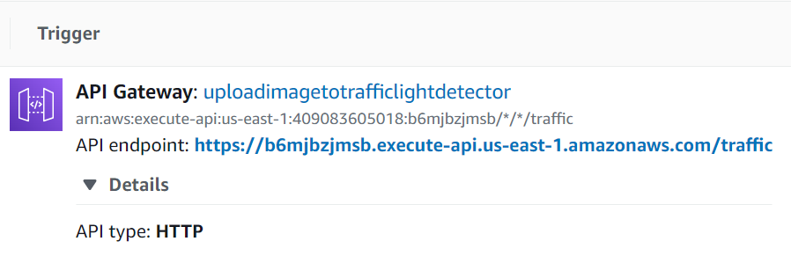

Figure 47 API endpoint for a lambda function as a trigger

# System integration and testing

## 6.1 Enrolment mechanism

The email two factor authentication and the forgot password mechanisms were tested and seem to be working well. Figures 48 and 49 below show the emails that are sent in case of new enrolment and forgetting password, in which the user will only needs to click on a link.

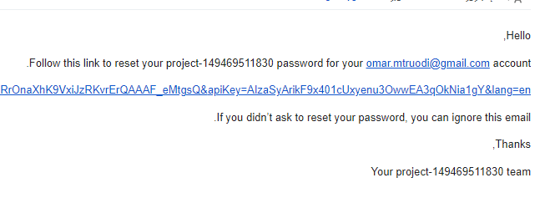

Figure 48, reset password email.

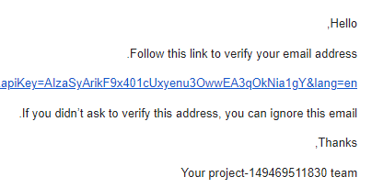

Figure 49, verify email message.

## 6.2 Switching in-between modes

Since the user is visually impaired, it is desired to allow them to move from one model to another in an easy manner that is suitable for them. Swiping the page seemed like a very good choice for changing the modes, it was implemented by creating a class that was primarily wrapped in a "PageView" widget, which would have each of the pages (classes) in which the user can swipe between. However, while each of the modes works well individually, once the swiping happens, it often leads to delay and even crashes the application in most cases.

As such, other options were explored. The first alternative was to utilize the volume buttons on the phone using the "volume_control". Once the user presses on the volume button, they would move to the next page (mode). However, this also resulted in the same issues encountered by the swiping method.

Finally, as a last resort, the whole page was wrapped in a widget called " gesturedetector", which allows for actions to be either on tap, on long press or any other known gesture [40]. Just as the last two options, the same behavior seemed to reoccur.

From looking into the issue and searching about the messages (these messages are not errors) shown in the debugging section, it seems like the issue is related to compatibility, where different phones yield different behaviors [41][42][43]. The final product was tested on multiple phones, and it showed inconsistent results, while some phones did not crash immediately in switching models, they all ended up crashing in the end in most instances. Occasionally, in a test it would not crash, but it is not consistent.

## 6.3 Text to speech

With the exception of the occasional crashes caused by switching in between the modes, every feature and use case work properly. For each of the modes, TTS works well with some intentional delay in the detect object mode in order to not spam it and cause inconvenience for the user. No TTS delay was needed for either of the OCR or traffic light modes, since by design frames to be sent are separated by a few seconds.

## 6.4 Live location

The live location feature works very well, but there are some occasional delays. In some cases, whenever the caretaker presses either the "track user" or "stop tracking" buttons shown in Figure 33(above in component design), there would be delay by a few seconds. Moreover, the "stop" status would be overwritten by a "collecting" status, but then after a few seconds would stop collecting the location of the blind user as intended.

# 7. User interface

## 7.1 Figma

The decision is narrowed down to Figma at the beginning. The reasons for that are that Figma is very flexible in design and can be converted to flutter easily. The reasons for narrowing it down to Flutter is because it is an open-source software development kit, and there are many modules that fit our project from Flutter.

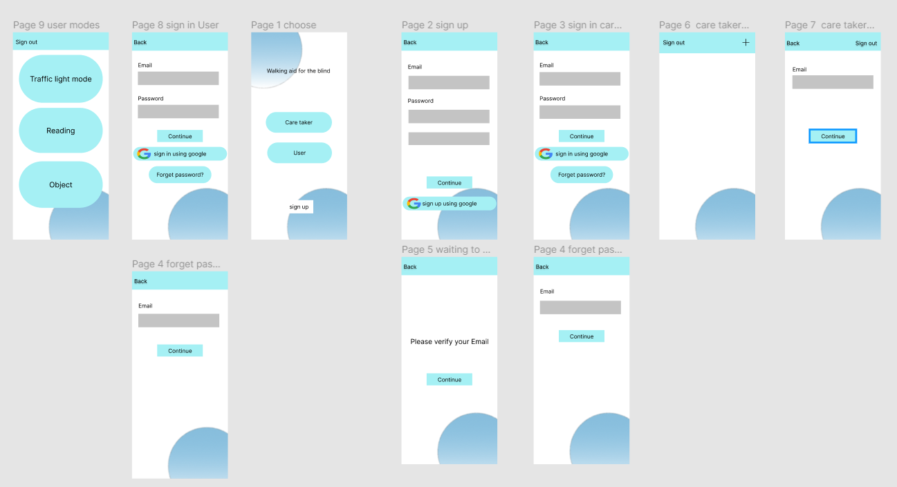

Figure 50. Figma design

But unfortunately, the integration between our models and the code translated from Figma to Flutter is time consuming due to the complexity of the translated code due to having extended classes. And the code models for location and object detection need to be alter and also the Figma code need to change to integrate very well to work. These are the reasons to not use Figma after finishing the work with Figma.

## 7.2 Native Flutter

The design required for the application is relatively simple, where only seven pages were required. Text fields and "Raisedbuttons" were utilized quite often to input user data or move to another page or do an operation in the back end. Some simple backgrounds were utilized with a light shade of grading, as can be seen in Figure 51.

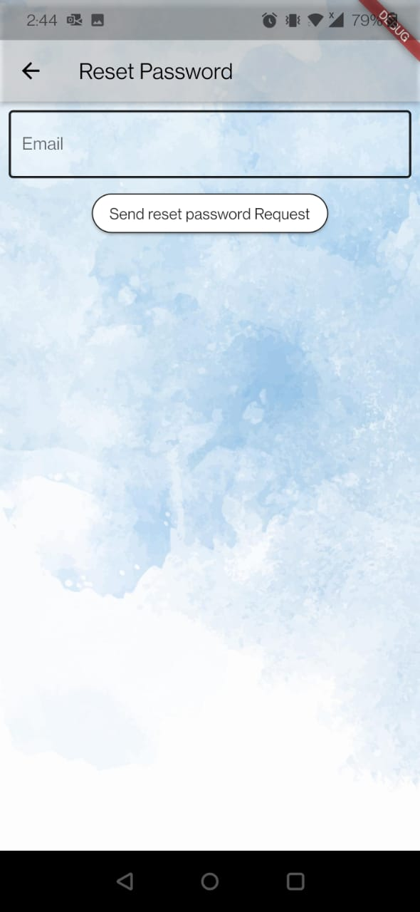 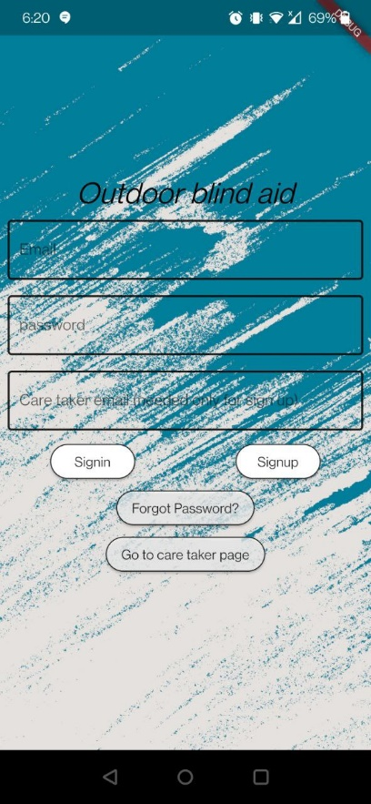

Figure 51, Sample user interface with background image.

While seven pages is a low number, it was desired to even reduce the number of pages, but it was not possible to put both the camera feed and user information in the same page, as it resulted in a "Pixel overflow" error. Hence the main menu page needed to lead to more pages for each of the modes to be selected by the user.

# Conclusion

To conclude, this project has passed three phases: project planning, solution design, and solution implementation. The project team finished all three phases within 15 weeks and was able to test all use-cases with the associated requirements, specifications, and constraints. The team, during the project phases, could apply several academic concepts, systematically learn more about solution design, experience the integration of a complete system and come up with a prototype, and finally enrich searching skills in different technical areas. Moreover, this project has shown some recent artificial intelligence applications and attempted to utilize them to help people and make the technology & science closer to humans. However, searching for recent AI models needed some amount of time to investigate, modify, and test because a lot of models are available, and finding a suitable model for the project makes it a challenging task. For instance, selecting OCR model took more than a month and after choosing paddleocr then it couldn’t be deployed on cloud smoothly, and then it was changed. The same applies to cloud computing, which is a good engineering practice because exploring the cloud providers, deployment approaches, and specifically Docker approach which consumes time due to building and pushing images. Therefore, this project could add more features, such as making the text detection bi-lingula, but due to time limitations and attempting different models then this could be considered as a possible enhancement. Even though there are more AI features and nice models that can be added, this project is generally extendable and can grow more and more.

# References

[1] “Fast facts of common eye disorders,” *Centers for Disease Control and Prevention*, 09-Jun-2020. [Online]. Available: https://www.cdc.gov/visionhealth/basics/ced/fastfacts.htm. [Accessed: 19-Jan-2022].

[2] الصحة فريق بوابة وزارة, “World sight day,” *Ministry Of Health Saudi Arabia*, 10-Oct-2019. [Online]. Available: https://www.moh.gov.sa/en/HealthAwareness/healthDay/2019/Pages/HealthDay-2019-10-10-001.aspx. [Accessed: 25-Jan-2022].

[3] Yan Wu Lecturer in Media and Communications, “Sight-impaired people want to use technology but are excluded by cost and accessibility - new research,” *The Conversation*, 13-Oct-2020. [Online]. Available: https://theconversation.com/sight-impaired-people-want-to-use-technology-but-are-excluded-by-cost-and-accessibility-new-research-103882. [Accessed: 19-Jan-2022].

[4] A. P. Horton, “These are the challenges that blind people have in navigating the Workplace,” *Fast Company*, 17-Oct-2019. [Online]. Available: https://www.fastcompany.com/90418293/the-challenges-of-being-blind-in-the-workplace. [Accessed: 06-Feb-2022].

[5] Darabont, Doru Costin & Badea, Daniel Onut & Trifu, Alina & Fogarassy, Paul. (2020). The impact of new assistive technologies on specific occupational risks for blind and visual impaired peoples. MATEC Web of Conferences. 305. 00079. 10.1051/matecconf/202030500079.

[6] A. Riazi, F. Riazi, R. Yoosfi, and F. Bahmeei, “Outdoor difficulties experienced by a group of visually impaired Iranian people,” *Journal of current ophthalmology*, 02-May-2016. [Online]. Available: https://www.ncbi.nlm.nih.gov/pmc/articles/PMC4909643/. [Accessed: 06-Feb-2022].

[7] “Libguides: Blind/Visual Impairment: Common Assistive Technologies,” *Common Assistive Technologies - Blind/Visual Impairment - LibGuides at University of Illinois at Urbana-Champaign*. [Online]. Available: https://guides.library.illinois.edu/c.php?g=526852&p=3602299. [Accessed: 06-Feb-2022].

[8] *About the UltraCane*. [Online]. Available: https://ultracane.com/about_the_ultracane. [Accessed: 06-Feb-2022].

[9] D. S. Zokaeim, “Coming soon: New assistive technology for the blind!,” *Assil Eye Institute Blog*, 12-Apr-2021. [Online]. Available: https://assileye.com/blog/new-assistive-technology-for-the-blind/. [Accessed: 06-Feb-2022].

[10] Amina Harit, Abdellah Ezzati, and Rachid Elharti. 2017. Internet of things security: challenges and perspectives. In <i>Proceedings of the Second International Conference on Internet of things, Data and Cloud Computing</i> (<i>ICC '17</i>). Association for Computing Machinery, New York, NY, USA, Article 167, 1–8. DOI:https://doi-org.kfupm.idm.oclc.org/10.1145/3018896.3056784

[11] M. G. on S. 15, “The 7 best apps to help people with visual impairments recognize objects,” *The 7 Best Apps to Help People with Visual Impairments Recognize Objects*. [Online]. Available: https://www.pathstoliteracy.org/technology/7-best-apps-help-people-visual-impairments-recognize-objects. [Accessed: 25-Feb-2022].

[12] X. Zhang, T. Lindberg, N. Xiong, V. Vyatkin, and A. Mousavi, “Cooling Energy Consumption Investigation of data center it room with vertical placed server,” *Energy Procedia*, vol. 105, pp. 2047–2052, May 2017.

[13] Robin, “How to dispose of E-waste in the Datacentre Industry,” *Server Room Environments*, 15-May-2021. [Online]. Available: https://www.serverroomenvironments.co.uk/blog/how-to-dispose-of-datacentre-ewaste. [Accessed: 27-Feb-2022].

[14] M. Stuart, “Microsoft's artificial intelligence is so smart it can tell blind people what's going on around them,” *Business Insider*, 30-Mar-2016. [Online]. Available: https://www.businessinsider.com/microsoft-artificial-intelligence-saqib-shaikh-2016-3. [Accessed: 12-Mar-2022].

[15] G. Alexiou, “Envision smart glasses – a game-changer in helping blind people master their environment,” *Forbes*, 28-Jan-2021. [Online]. Available: https://www.forbes.com/sites/gusalexiou/2021/01/28/envision-ai-glasses--a-game-changer-in-helping-blind-people-master-their-environment/?sh=65787f5db85e. [Accessed: 12-Mar-2022].

[16] T. Macaulay, “Google's AI-powered smart glasses help the blind to see,” *TNW | Plugged*, 09-Mar-2020. [Online]. Available: https://thenextweb.com/news/googles-ai-powered-smart-glasses-help-the-blind-to-see. [Accessed: 12-Mar-2022].

[17] Li Yan, Xiaowei Hao, Zelei Cheng, and Rui Zhou. 2018. Cloud Computing Security and Privacy. In <i>Proceedings of the 2018 International Conference on Big Data and Computing</i> (<i>ICBDC '18</i>). Association for Computing Machinery, New York, NY, USA, 119–123. DOI:https://doi-org.kfupm.idm.oclc.org/10.1145/3220199.3220217

[18] H. Takabi, J. B. D. Joshi and G. Ahn, "Security and Privacy Challenges in Cloud Computing Environments," in IEEE Security & Privacy, vol. 8, no. 6, pp. 24-31, Nov.-Dec. 2010, doi: 10.1109/MSP.2010.186.

[19] /* custom css */.tdb-post-meta{ margin-bottom: 16px; color: #444; font-family: 'Open Sans', S. Hiter, By, S. Hiter, Chris Ehrlich - March 9, and C. E. -, “Cloud computing jobs: Market, salary, & career options 2022,” *Datamation*, 22-Dec-2021. [Online]. Available: https://www.datamation.com/careers/cloud-computing-job-market/. [Accessed: 13-Mar-2022].

[20] “Computer and Information Technology Occupations : Occupational Outlook Handbook,” *U.S. Bureau of Labor Statistics*, 08-Sep-2021. [Online]. Available: https://www.bls.gov/ooh/computer-and-information-technology/home.htm. [Accessed: 13-Mar-2022].

[21] Gav L. (2020). *What Size Are Smartphone Photos?* The Smartphone Photographer. Retrieved from https://thesmartphonephotographer.com/size-of-smartphone-photos/

[22] Gav L. (2020). *What Size Are Smartphone Photos?* The Smartphone Photographer. Retrieved from https://thesmartphonephotographer.com/size-of-smartphone-photos/

[23] “See a cloud Firestore pricing example  |  firebase documentation,” *Google*. [Online]. Available: https://firebase.google.com/docs/firestore/billing-example#:~:text=Brief%20review%20of%20Cloud%20Firestore,the%20network%20bandwidth%20you%20use. [Accessed: 16-Mar-2022].

[24] M. Chand, “Top 10 cloud service providers in 2021,” *C# Corner*. [Online]. Available: https://www.c-sharpcorner.com/article/top-10-cloud-service-providers/#:~:text=AWS%20is%20the%20most%20popular,used%20by%20millions%20of%20customers. [Accessed: 16-Mar-2022].

[25] “Historic documents relating to the organization of the State of Indiana: Papers showing the transfer of ownership of what is now the state of Indiana, from the State of Virginia to the United States government. also the AWS and Odinances showing the orgainzation of the territory, and later the state of Indiana. for use by the Terre Haute Public Schools,” *Amazon*, 1917. [Online]. Available: https://aws.amazon.com/what-is-aws/#:~:text=Amazon%20Web%20Services%20(AWS)%20is,services%20from%20data%20centers%20globally. [Accessed: 16-Mar-2022].

[26] A. Mishra, “Machine learning in the AWS cloud: Add intellegence to appllcatgions with Amazon Sagemaker and Amazon Rekognition,” *Amazon*, 2019. [Online]. Available: https://aws.amazon.com/sagemaker/pricing/?nc=sn&loc=3. [Accessed: 16-Mar-2022].

[27] A. Besbes, “How to build and deploy a serverless machine learning app on AWS,” *Medium*, 01-Oct-2021. [Online]. Available: https://towardsdatascience.com/how-to-build-and-deploy-a-serverless-machine-learning-app-on-aws-1468cf7ef5cb. [Accessed: 16-Mar-2022].

[28] “Develop & Monitor apps on Aws Lambda,” *Serverless*. [Online]. Available: https://www.serverless.com/. [Accessed: 16-Mar-2022].

[29] “S3,” *Amazon*, 2002. [Online]. Available: https://aws.amazon.com/s3/. [Accessed: 16-Mar-2022].

[30] “10 things you might not know about using AWS S3,” *Sumo Logic*. [Online]. Available: https://www.sumologic.com/insight/10-things-might-not-know-using-s3/. [Accessed: 16-Mar-2022].

[31] “Amplify framework docs,” *Amplify icon*. [Online]. Available: https://docs.amplify.aws/. [Accessed: 16-Mar-2022].

[32] P. Stud, “What is AWS amplify? -advantages and disadvantages of AWS Amplify,” *Medium*, 29-Mar-2021. [Online]. Available: https://medium.com/analytics-vidhya/what-is-aws-amplify-advantages-and-disadvantages-of-aws-amplify-49ddc4831467#:~:text=How%20does%20AWS%20Amplify%20Work%3F&text=Using%20AWS%20Amplify%2C%20you%20can,and%20multiple%20other%20applications'%20features. [Accessed: 16-Mar-2022].

[33] STC. (n.d.). *Quicknet 4G Unlimited Internet 6 Mbps - stc*. STC. Retrieved from https://www.stc.com.sa/wps/wcm/connect/english/individual/static/quicknet4grouter

[34] DERUDDER, K. (2019, February). *Which direct messaging application should I choose?* Greenspector. Retrieved from https://greenspector.com/en/which-direct-messaging-application-should-i-choose/

[35] Triggs, R. (2018). *Fact check: Is smartphone battery capacity growing or staying the same?* ANDROID AUTHORITY. Retrieved from https://www.androidauthority.com/smartphone-battery-capacity-887305/

[36] “MySQL VS nosql: Top comparison to learn with infographics,” *EDUCBA*, 01-Mar-2021. [Online]. Available: https://www.educba.com/mysql-vs-nosql/. [Accessed: 28-Apr-2022].

[37] “Get data with cloud firestore  |  firebase documentation,” *Google*. [Online]. Available: https://firebase.google.com/docs/firestore/query-data/get-data#dart. [Accessed: 28-Apr-2022].

[38] “Get realtime updates with Cloud Firestore  |  firebase documentation,” *Google*. [Online]. Available: https://firebase.google.com/docs/firestore/query-data/listen. [Accessed: 28-Apr-2022].

[39] Samdan, E. (n.d.). *Aws Lambda Limits to keep in mind when developing a serverless application*. Thundra Blog. Retrieved April 30, 2022, from https://blog.thundra.io/aws-lambda-limits-to-keep-in-mind-when-developing-a-serverless-application#:~:text=There%20is%20a%20hard%20limit%20of%206mb%20when%20it%20comes,their%20AWS%20S3%20asset%20storage.

[40] “Gesturedetector class null safety,” *GestureDetector class - widgets library - Dart API*. [Online]. Available: https://api.flutter.dev/flutter/widgets/GestureDetector-class.html. [Accessed: 05-May-2022].

[41] Realm, “Fatal signal 11 (SIGSEGV), Code 1, Fault Addr 0x8 in TID 26062 (asynctask #2) · issue #6362 · realm/realm-java,” *GitHub*. [Online]. Available: https://github.com/realm/realm-java/issues/6362. [Accessed: 05-May-2022].

[42] Flutter, “Flutter app crashes on startup when running in release mode on IOS · issue #19858 · Flutter/Flutter,” *GitHub*. [Online]. Available: https://github.com/flutter/flutter/issues/19858. [Accessed: 05-May-2022].

[43] “Crash on Android with signal 11 (SIGSEGV), Code 1 (SEGV_MAPERR), Fault Addr 000000F0,” *Unity Forum*. [Online]. Available: https://forum.unity.com/threads/crash-on-android-with-signal-11-sigsegv-code-1-segv_maperr-fault-addr-000000f0.496838/. [Accessed: 05-May-2022].

[44] Text detection and extraction using OpenCV and OCR. (2020, February 19). GeeksforGeeks. https://www.geeksforgeeks.org/text-detection-and-extraction-using-opencv-and-ocr/

[45] Mishra, A. (2019). *Machine learning in the AWS cloud: Add intelligence to applications with Amazon Sagemaker and Amazon Rekognition*. Amazon. Retrieved May 6, 2022, from https://aws.amazon.com/rekognition/

[46] *Multiple color detection in real-time using python-opencv*. GeeksforGeeks. (2020, May 10). Retrieved May 7, 2022, from https://www.geeksforgeeks.org/multiple-color-detection-in-real-time-using-python-opencv/

[47] Solarian programmer. (n.d.). Retrieved May 7, 2022, from https://solarianprogrammer.com/2015/05/08/detect-red-circles-image-using-opencv/

[48] PaddlePaddle. (n.d.). *Paddlepaddle/PADDLEOCR: Awesome multilingual OCR toolkits based on paddlepaddle (practical ultra lightweight OCR system, support 80+ languages recognition, provide data annotation and synthesis tools, support training and deployment among server, mobile, embedded and IOT devices)*. GitHub. Retrieved May 7, 2022, from https://github.com/PaddlePaddle/PaddleOCR

[49] *Convert text to speech in python*. GeeksforGeeks. (2021, August 15). Retrieved May 7, 2022, from https://www.geeksforgeeks.org/convert-text-speech-python/

# Appendix

1. Omar’s work: [Omar's work.rar](https://kfupmedusa-my.sharepoint.com/:u:/g/personal/s201773270_kfupm_edu_sa/Ee753bMXXuZJsGjmgo40LmUBc1vnZYUFVEkwi8HnrlACxw?e=F4c84X)
2. Hasan’s work: [Hasan's work](https://drive.google.com/drive/folders/1W2m-_QjaH_WySnaTii7bH5t0VzZ3nqDD?usp=sharing)
3. Mojtaba’s Work: [Mojtaba’s work](https://docs.google.com/document/d/1ssP5_3jzur_CAvxUUZnpZOtFxei8Me44/edit?usp=sharing&ouid=113881514945933055181&rtpof=true&sd=true)
4. Hashim’s work: [SDP work](https://kfupmedusa-my.sharepoint.com/:f:/g/personal/s201678700_kfupm_edu_sa/ElxpWczO9gxPnQQXCjMcOkIBUiIISVvf9FZNJxq80EdjCA?e=QBHzMK)
5. Source code: [Project(latest).rar](https://kfupmedusa-my.sharepoint.com/:u:/g/personal/s201773270_kfupm_edu_sa/Eb1Np2eLgQlApAOnQeiPfeYBaeag9LN5l_lozkqjxxLpkg?e=Pm2ENK)
6. Meeting minutes: [Meeting minutes.rar](https://kfupmedusa-my.sharepoint.com/:u:/g/personal/s201773270_kfupm_edu_sa/EdkiWWETR59OiZPQF_YeuVUBUe2-Jjtj37dutlhsCtAFsw?e=HpFSXA)